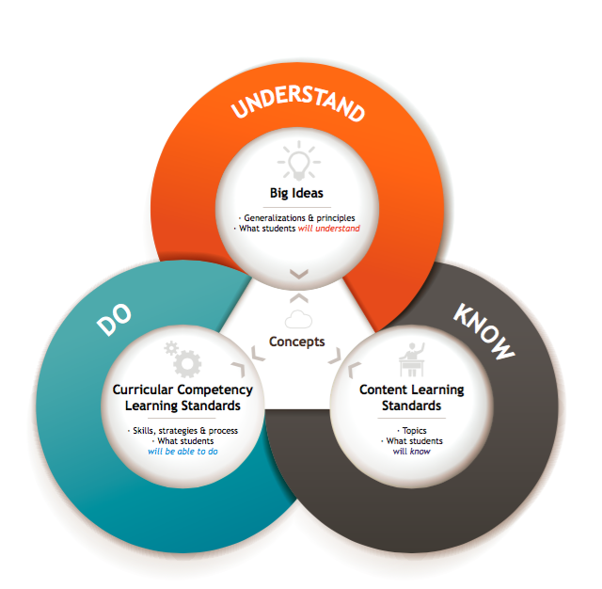
Do (Curricular Competencies) Know (Content)
Formative Assessment

Learning
Experiences

Role play 
Interviews 
Observations 

Response writing 
Feedback Frames 
Reflection Questions  _____________ 

Big Idea / Essential Question - Understand

Resources

Summative Assessment

How will students demonstrate
their understanding? What evidence will you look for?

Student Inquiry Core Competencies

Students’ voices and questions.
 Communication

 Critical Thinking

 Creative Thinking

 Social Responsibility
 Personal Awareness and Responsibility

 Positive Personal and Cultural Identity

