Math Workshop
The Daily Five the ‘Math Way’

Introduction:
- rationale – provide opportunities for teachers to work with groups of students to meet their needs
- guided math instruction – targeted learning intentions with groups of students
- engagement in the mathematical processes
- sense making model
- engaged learners

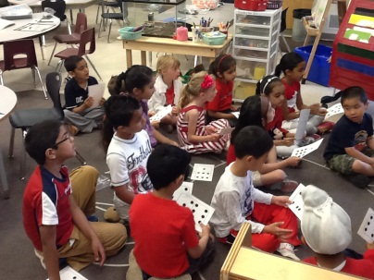
Math Workshop Framework: (at least 3 times a week)
1. Whole Group instruction need to happen every day – 5 – 10 minutes
- introduces concepts, activities or reviews strategies

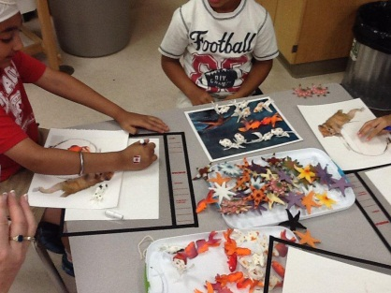
2. Math workshop – 40 – 50 minutes long
-includes four areas
- Math with Someone
- Math by Myself
- Links to Literature
- Guided Math Group
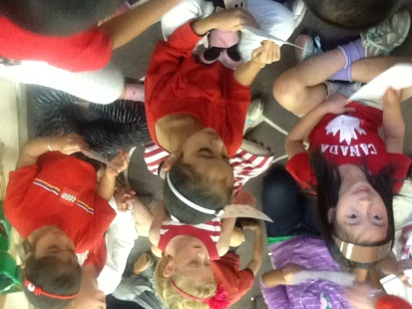
3. Connect and Reflect – 10 minutes

Starting Up:
Getting to Know Your Students:
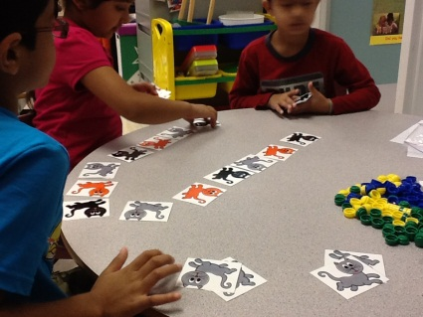
- need to know your students strengths, interests, passions and area to develop
- WDTK – K – focus on subitizing and counting – initial K
and a counting assessment
- Grade 1 – Final K or Initial Grade 1 or Grade Specific
- Grade 2 – Final Grade 1 or Grade Specific
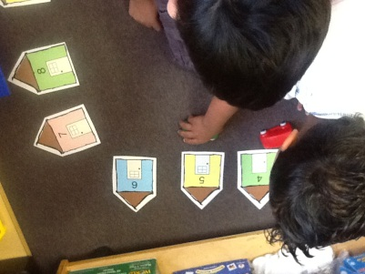
- Whole group counting and sorting activities – explaining their thinking

Setting the Stage (the math environment):
- physical structure of the room and materials
- building a math community that is safe, promotes risk taking and develops mutual respect for all

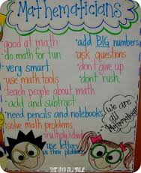
Creating Anchor Chart with the students
- What is a mathematician? Mathematizing
- What are we doing and why?
- purpose
- concepts
- connections
- What will it look like?
- layout
-expectations
- How will I know I am understanding? – making meaning
- How do I know I am a mathematician?

Math Workshop:
- Math with Someone – games and activities
- students need to know what to do (comfortable and have practiced the games)
- need to develop clear guidelines and expectations
- need to apply social skills
- need to self-regulate
- need to take care of materials
- need to choose appropriate locations
- focus on building fluency, applying strategies and communicating their ideas
- Math by Myself – independent activities
- writing prompts
- spatial tasks
- story mats
- open ended and parallel tasks
- number tile puzzles
- rich routines
- counting collections
- sorting
- working with dot cards, five/ten frames, dominoes, rekenreks, manipulatives
- IPICK – tools - I pick tools that will help me and I know why I pick them
- pictures of various tools would be helpful
- focus on building and applying understanding
- Links to Literature – posters, pocket charts, trade books, Tumblebooks
- inquiry based activities
- focus on representing and recording ideas
- choose a lead book that would be introduced and worked with the Whole group
- Lead book would set the stage
- family of books that are conceptually related would be available
- rich tasks
- focus on inquiry
- focus on concretely, pictorially and symbolically representing
ideas
Guided Math Groups – 2 groups a day – 20 minutes each
- no more than 5 students, no less than 3
- groups need to be flexible to meet the changing needs of the students
- Focus on Big Ideas in Math
- Numbers can be represented in many ways
- comparing and ordering numbers
- number operations
- materials – dot cards, five/ten frames, manipulatives, dominoes, skillboards
- incorporate NUMBER TALKS
- focus on subitizing, partitioning and mental math strategies
- Assessment for Learning must be embedded – Look at Math Exchanges
- role of the teacher – good questions to ask.

Planning Sheet:

Strand: Number | Big Idea:
Whole Group:

Guided Math Instruction: | Math by Myself
Math With Someone | Links to Literature
Connect and Reflect: | Looking Ahead

