Elementary Math Workshops
With Carole Fullerton
Nov 7, 2017
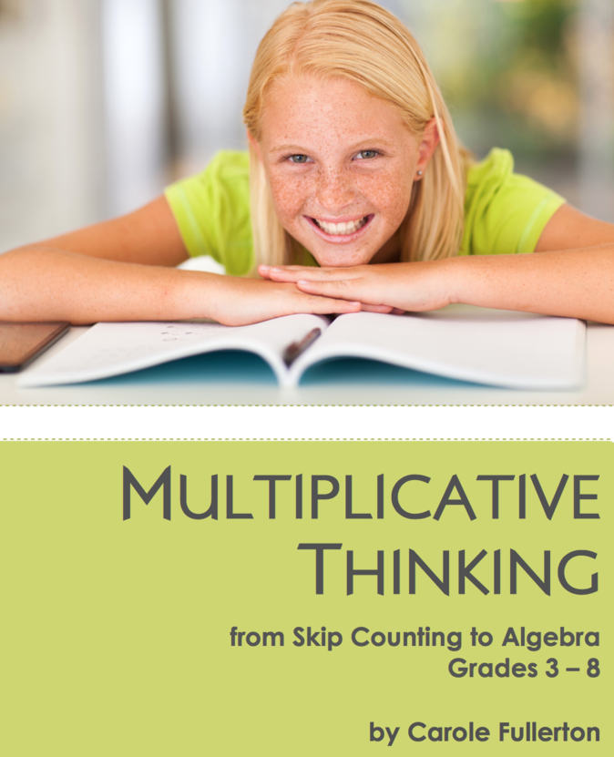
Burnaby North Secondary—Gallery

9 am – 11:45
Multiplicative Thinking
for
Intermediate Students

12:45-3 pm
Facts and Place Value
for
Primary Students

Register on the Staff Development Calendar.

For more information, contact Donna Morgan, Math/Science Program Consultant at donna.morgan@sd41.bc.ca or 604-760-6157
Elementary Math Workshops
With Carole Fullerton
Nov 7, 2017

Carole Fullerton is a private consultant working with teachers around British Columbia (and beyond!) in the area of numeracy. She works with districts, whole school staffs, with school-based learning teams, in classrooms and with parents in an effort to promote mathematical thinking.

Multiplicative Thinking for Intermediate Students
Multiplicative thinking is a set of essential understandings about the patterns within and between numbers. From skip counting to multiples, from "groups of" and "rows of" to the multiplication of larger numbers using the distributive property, from T-tables to algebraic reasoning, multiplicative thinking is has a huge role to play in developing a solid sense of number.

Facts and Place Value for Primary Students
This workshop will present developmentally framed lessons designed to address the diversity in our primary classrooms. Each one supports students to represent and describe quantity, to compare and order sets, to use referents to estimate and to skip count.

