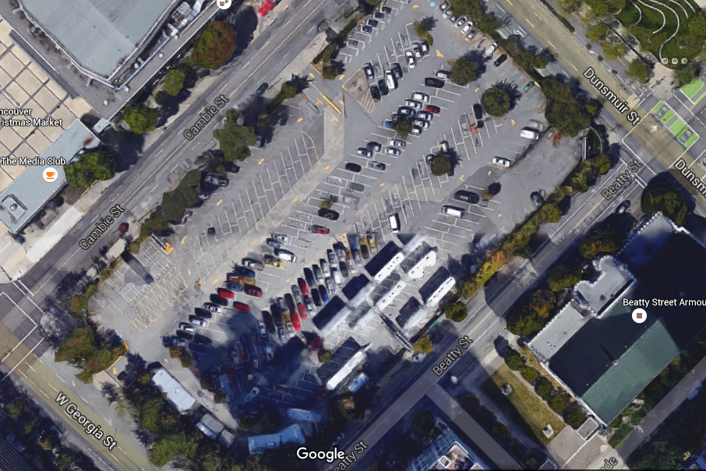
Problem Solving Framework:
Define the Problem
What question(s) do you have?

Analyze the Problem
What do you know/notice from the problem scenario or previous lessons that can help solve the problem? | What concepts or information do you need to know in order to solve the problem?
Brainstorm Strategies for Solving the Problem
What strategies might you use to solve the problem? How will you start the problem?

