Excerpts from November 2015 post to BCAMT math listserv
(by Robert Lovell - teacher at St. George’s School)

If you are teaching Math 8, or like to make Real World Connections, or like to bring informed relevant discussions into the classroom that develop mathematical thinking…here’s a tidbit.

I was reading the news yesterday and came across this article: 1 in 5 children in BC living in poverty.

The article references StatCan ‘Low Income Measure’ but didn’t get into the details.
I looked it up and noticed they use a square root in the formula.

Low Income if:
household income < (50% of Canada's median income) x

where N =number of family members

So as a ‘real world’ connection with Math 8 students, you can use the newspaper article as an entry document, discuss, then dig deeper into the quantitative side. You could have students calculate the cut-offs for ‘low income’ by creating a table like the one below:

Example: 4 people living in your household.
Canada median income in 2011 = $22,160.
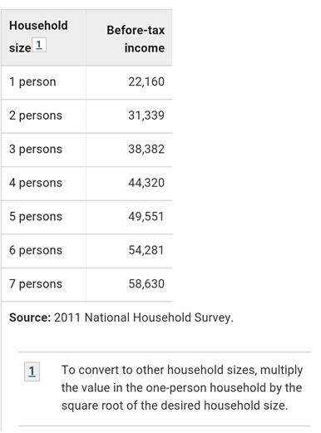
- so if in 2011, with 4 people living in house, if total household income before tax was under $44,320 then household is "low income" by the measure in the article.

If you want your students to dig deeper into the data, this CANSIM table lets you explore data (e.g. go to Add/Remove – could look just at Median Income, but add BC and several other provinces or compare major Canadian cities, etc. )

Cheers,

Rob Lovell | Teacher
St. George's School
604-224-1304

