My Heart Map

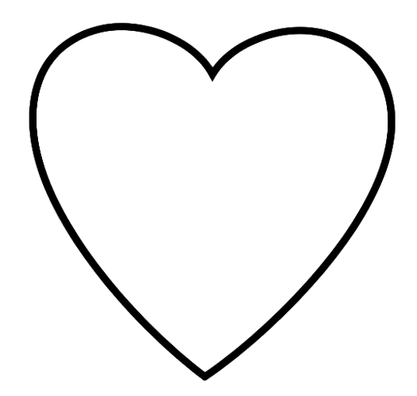
Draw or write special things in your life. These could be people, things, places, or memories.

