Powerful Understanding – Adrienne Gear
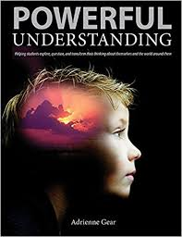

Learning | Understanding
The taking in (memorizing) of information about a topic from teacher, text and other sources and retelling or regurgitating it.  Literal learning | Interacting with that information and developing new thinking on the topic. Reflect and Rethink.  Transformative understanding

To demonstrate deep understanding, learners MUST be able to show…
- How has your thinking developed? Stretched? Been transformed?
- How are you different because of what you have just learned?
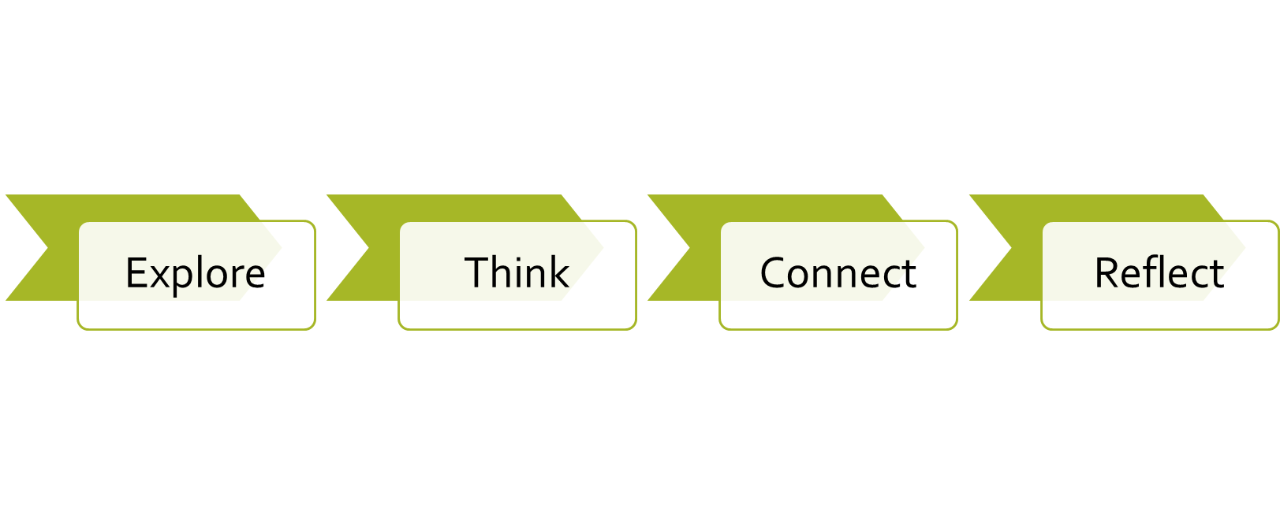
The Powerful Understanding Model:

What does critical thinking look like?
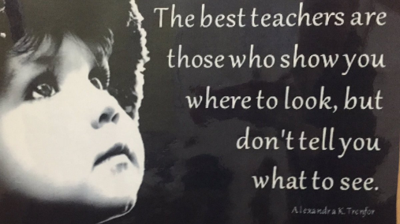

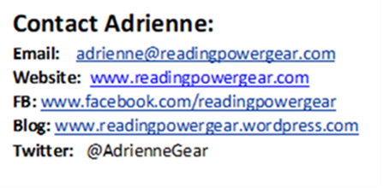

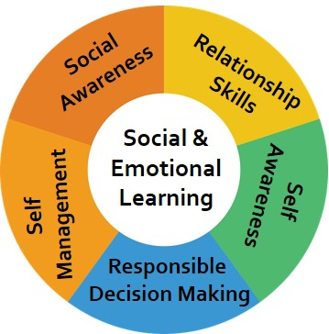
“To achieve our educational goals, we need to promote social emotional literacy as well the three “R”s. The purpose of education is to enable children to be life-long learners and effective citizens.”
(Jonathan Cohen, 2001. Director of the Program for Social and Emotional Learning at Teachers College, Columbia University.)

Powerful Understanding:
- Understanding Self – My Name, Celebrate Me, My Family, My Culture, My Moral Compass, My Feelings, My Hopes and Dreams
- Understanding Others – Friendships, Empathy, Inclusion, Diversity, My Social Footprint, My Local Community
- Understanding the World – Global Citizenship, Global Justice, Global Education, Global Footprint, Peace, Privilege and Poverty

Anchor Books for Powerful Understanding Lessons
UNDERSTANDING SELF
*Why Am I Me? – Paige Britt
My Name:
Too Many Daves – Dr. Seuss
Thunder Boy Junior – Sherman Alexie
Chrysanthemum – Kevin Henkes
The Change Your Name Store - Leanne Shirtliffe
What’s In A Name? – Nichola Batzel (indigenous)
Alma and How She Got Her Name - Juana Martinez-Neal

Celebrate Me:
I Like Me! – Nancy Carlson
I Like Myself! - Karen Beaumont
Excellent Ed - Stacy McAnulty
Looking Like Me! – Walter Dean Myers
My Nose, Your Nose – Melanie Walsh

My Family:
A Family is a Family is a Family – Sara O’Leary
The Family Book – Todd Parr
The Great Big Book of Families – Mary Hoberman
My Family Tree and Me – Dušan Petričić

My Culture and Cultural Celebrations
Cultural Traditions in Canada - Molly Aloian
Families Around the World – Margriet Ruurs

Celebrations cont.
This Is How We Do It: One Day in the Lives of Seven Kids from around the World - Matt Lamothe
Islandborn - Junot Diaz
Kids Around the World Celebrate!: The Best Feasts and Festivals from Many Lands - Lynda Jones
Bringing in the New Year – Grace Lin
Pesk’a and the Salmon Ceremony – Scott Ritchie (Indigenous)

My Grandparents
Tangerines and Tea, My Grandparents and Me –
The Hello-Goodbye Window – Norton Juster
A Morning with Grandpa – Sylvia Lui
Lessons from Mother Earth – Elaine McLeod
Last Stop on Market Street – Matt de la Pena
Drawn Together - Minh Le

My Personal Preferences
I Like Bees, I Don’t Like Honey – Sam Bishop
Red Rockets and Rainbow Jelly – Sue Heap

Feelings
Feelings, Cont.
The Way I Feel – Janine Cain
The Feelings Book – Todd Parr
Finn Throws a Fit – David Elliott
Out, Out, Away From Here – Rachel Woodward
Sam's Pet Temper - Sangeeta Bhadra
The Red Tree – Shaun Tan
Small Things – Meg Tragonning
Mindfulness
Now – Antoinette Portis
I Am Peace – A Book of Mindfulness – Susan Verde
Take the Time: Mindfulness for Kids – Maud Roegiers

My Moral Compass
Big Red Lollipop - Rukhsana Khan
A Bike Like Sergio’s – Meribeth Boelts
Summer My Father Was Ten – Pat Brisson

My Unique Self
Be Who You Are! - Todd Parr
It’s OKAY to be Different – Todd Parr
Lovely – Jess Hong
Beautiful – Stacy McAnulty
The Boy Who Grew Flowers - Jen Wojtpwocz
Oddrey – Dave Whamond
Green Pants – Kenneth Kraegel

UNDERSTANDING OTHERS

Friendship
Be A Friend – Salina Yoon
How to Be a Friend: A Book About Friendship - Michaelene Mundy
You Are Friendly – Todd Snow
The Best Friends Book – Todd Parr

The Friendship Fix
Draw the Line – Katheryn Otoshi
I’m the Best! – Lucy Cousins
The Worst Best Friend – Alexis O’Neil
Chester’s Way – Kevin Henkes
That’s (Not) Mine! - Anna Kang
Friendship is Like a SeeSaw – Shona
Innes

Being Friendly
Mean Jean the Recess Queen – Alexis O’Neill
Hooway for Wodney Wat - Helen Lester
Enemy Pie – Derek Munsoon
Invisible Boy – Trudy Ludwig
The Outlaw – Nancy Vo
What Happens Next? – Susan Hughes

Inclusion
Strictly No Elephants - Lisa Mantchev
The Big Umbrella - Amy June Bates
I'm Not Invited? - Diana Cain Bluthenthal
All Are Welcome - Alexandra Penfold
We Are All Dots - Giancarlo Macrì
A Very Big Bunny - Marisabina Russo
I Wasn’t Invited to the Birthday - Susanna Isern
Eddy Longpants – Merielle Levert
Marshall Armstrong is New to Our School – David Mackintosh

Diversity
Do I Look Odd To You? - James McDonald
Why Am I Me? – Paige Britt
Let’s Talk About Race – Julius Lester
Lovely – Jess Hong
Chocolate Milk, Por Favor: Celebrating Diversity with Empathy - Maria Dismondy
Wherever You Are – Mem Fox
Most People – Michael Leaanna

Kindness
Be Kind - Pat Zietlow Miller
What Does It Mean to Be Kind? – Rana DiOrio
Each Kindness – Jacqueline Woodson
Good People Everywhere - Lynea Gillen
Come with Me! – Holly M. McGhee
If You Plant a Seed – Kadir Nelson
The Jelly Donut Difference: Sharing Kindness with the World – Maria Dismondy
Heartprint – P.K. Hallinan

My Social Footprint – (Action-Reaction)
What If Everybody Did That? - Ellen Javernick
What If Everybody Said That – Ellen Javernick
The Way I Act – Steve Metzger
The Bad Seed – Jory John
Adrian Simcox Does NOT Have a Horse – Marcy Campbell
Ruthie and the Not So Teeny Tiny Lie – Laura Rankin
Edward Fubwupper Fibbed Big – Berkeley Breathed
Sam Tells Stories – Thierry Robberecht
Mr. Peabody’s Apples – Madonna

Empathy
I Am Human: A Book of Empathy – Susan Verde
Stand in My Shoes – Bob Sornson
I’m New Here – Anne Sibley O’Brian
That Neighbor Kid - Daniel Miyares
My Name is Sangoel – Karen Willia

Community
Counting on Community - Innosanto Nagara
What Can a Citizen Do? - Dave Eggers
Look Where We Live: A First Book of Community Building – Scott Ritchie
Can We Help?: Kids Volunteering to Help Their Communities - George Ancona
Maybe Something Beautiful: How Art Transformed a Neighborhood - F. Isabel Camp

UNDERSTANDING THE WORLD

GLOBAL JUSTICE
Colonization
Encounter – Jane Yolen (Christopher Columbus)
The Rabbits - John Marsden
Emancipation
The Patchwork Path: A Quilt Map to Freedom – Betty Stroud
Underground – Christopher Evans
Segregation/ Racism
White Socks Only – Evelyn Coleman
Freedom Summer - Deborah Wiles
Separate is Never Equal – Duncan Tonatium
Assimilation
I Am Not a Number – Jenny K Dupuis
When We Were Alone – David Alexander Robertson
Stolen Words – Melanie Florence
Dictatorship
Sparrow Girl – Sarah Pennypacker
The Composition – Antonio Skarameta
Censorship
The Stamp Collector – Jennifer Lanthier
Secret of the Dance – Andrea Spalding (banning of The Potlatch)
Civil Rights
Viola Desmond Won’t Be Budged - Jody Nyasha Warner
Rosa – Nikki Giovanni
I Have a Dream - Dr. Martin Luther King Jr
Persecution
The Harmonica - Tony Johnston (Holocaust)
Rose Blanche – Christophe Gallaz (Holocaust)
Naomi's Tree - Joy Kogawa (Japanese Interment Camp)
Exploitation
Brave Girl: Clara and the Shirtwaist Makers' Strike of 1909 - Michelle Markel (P,I)
I Like, I Don’t Like - Anna Baccelliere (I)
Malala, a Brave Girl from Pakistan/Iqbal, a Brave Boy from Pakistan: Two Stories of Bravery - Jeanette Winter (I)
Immigration
Gleam and Glow – Eve Bunting
A Different Pond – Bao Phi
Stepping Stones – Margruit Ruurs
Adrift at Sea: A Vietnamese Boy's Story of Survival - Marsha Forchuk Skrypuch
My Wounded Island - Jacques Pasquet (climate refugees)
Dreamers – Yuyi Morales
Mustafa – Marie Louise Grey
Someone New – Anne Sibley O’Brien (could also be kindness)
The Dress and the Girl – Camille Andros

Refugee Crisis
The Banana Leaf Ball – Katie Smith Milway
My Name is Not Refugee – Kate Milner
Four Feet, Two Sandals – Karen Lynn Williams
My Beautiful Birds – Suzanna Del Rizzo

PEACE
The Peace Book – Todd Parr
What Does Peace Feel Like? – Vladamir Radunsk
Can You Say Peace? – Karen Klatz
Peace is an Offering – Annette LeBox
What Is Peace? – Wallace Edwards
Peace – Wendy Anderson

GLOBAL CITIZENSHIP – Change Agents
Paths to Peace: People Who Changed the World - Jane Breskin Zalben
People of Peace: 40 Inspiring Icons - Sandrine Mirza
Spirit Bear and Children Make History – Cindy Blackstock
Rice From Heaven – Tina M. Cho
One Peace: True Stories of Young Activists – Janet Wilson
Here We Go: A Poetry Friday Power Book - Sylvia Vardell and Janet Wong
A is for Activist – Inosanto Nagara
Weezer Changes the World - David McPhail
Malala, a Brave Girl from Pakistan/Iqbal, a Brave Boy from Pakistan: Two Stories of Bravery - Jeanette Winter

GLOBAL FOOTPRINT What Does it Mean to Be Green? – Dana Di Orio
Common Ground: The Water, Earth, and Air We Share - Molly Bang
A Forest - Marc Martin
Sandy's Incredible Shrinking Footprint - Femida Handy
S is for Save the Planet: A How-To-Be Green Alphabet - Brad Herzog
My Green Day – Melanie Walsh
Ten Things I Can Do to Help My World – Melanie Walsh
The Earth Book – Todd Parr
Our Gift-Filled Earth - Eun Hee Na

PRIVILEDGE, POVERTY, and HOMELESSNESS
I Like, I Don’t Like - Anna Baccarillia
If the World Were a Village - David J Smith
Voices in the Park – Anthony Brown
Maddi’s Fridge – Louis Brandt
Poverty and Hunger - Louise Spilsbury
On Our Street: Our First Talk About Poverty - Dr. Jillian Roberts
Maddie’s Fridge – Lois Brandt
OTHER INSPIRATIONAL BOOKS:
Love - Matt de la Peña
Life – Cynthia Rylant
Here We Are: Notes for Living on Planet Earth -- Oliver Jeffers
Thank you, Earth –
We Are All Dots: A Big Plan for a Better World -Giancarlo Macri

Those Shoes – Maribeth Boelts
The Teddy Bear – David McPhail

READING AND THINKING ACROSS CANADA
Emma and the Silk Train - Julie Lawson (BC)
Saving Thunder Great - Leanne Shirtcliff (Alberta)
Li’l Shadd: A Story of Ujima - Miriam Korner (Saskatchewan)
Finding Winnie - Lindsay Mattick (Manitoba)
Into the Woods - Rebecca Bond (Ontario)
The Stone Thrower - Jael Earley Richardson (Ontario)
Just Like New - Ainslie Manson (Quebec)
The Sugaring-Off Party -Jonathon London (Quebec)
Free as the Wind: Saving the Wild Horses on Sable Island - Joseph Bastille (Nova Scotia)
Boy of the Deeps - Ian Wallace (Nova Scotia)
Viola Desmond Won’t Be Budged - Jody Nyasha Warner (Nova Scotia)
Change of Heart - Alice Walsh (Newfoundland)
Return to the Sea - Heidi Jardine Stoddart (New Brunswick) ?
The Summer of Marco Polo - Lynn Manuel (P.E.I.)
Klondike Cat - Julie Lawson (Yukon)
Wild Eggs – Suzie Napayok-Short (Arctic - NW Territories)
The Gift of the Inukshuk - Michael Ulmer (Nunavik)

Powerful Understanding Model
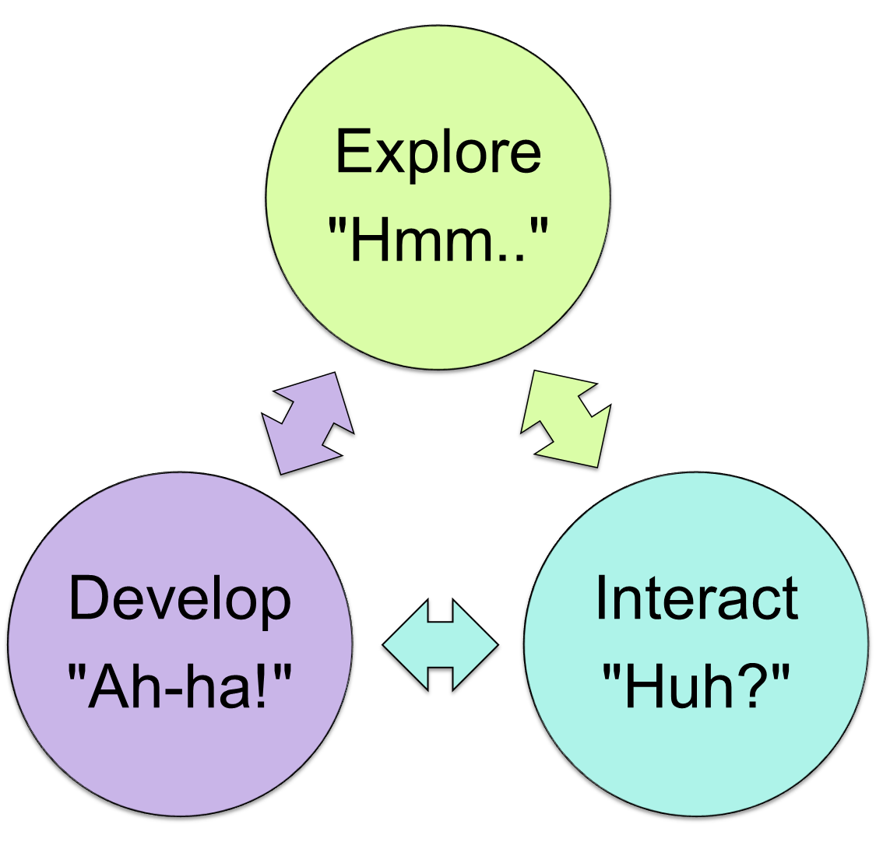

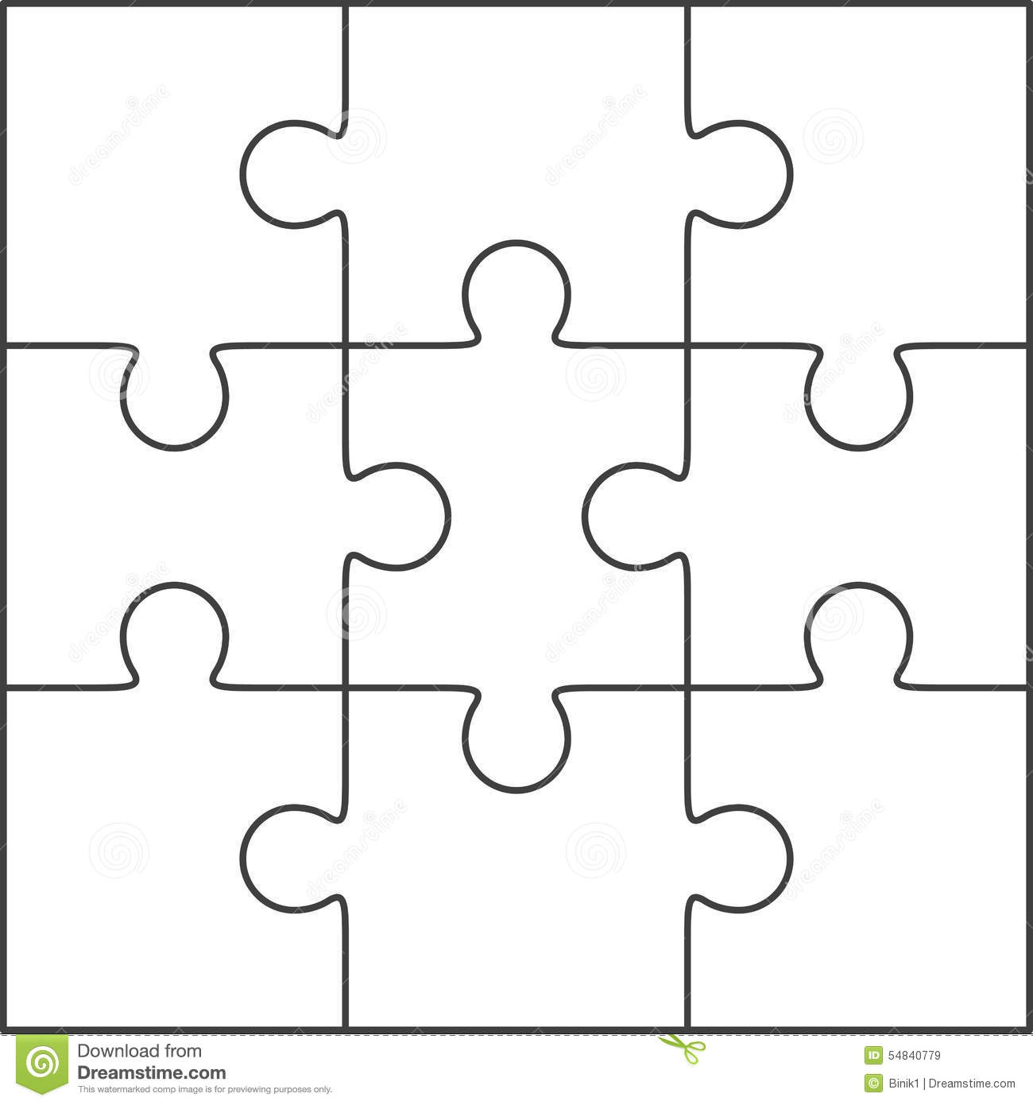
The Many Pieces of ME!
ME

Who Am I?
___________

Connect – Reflect!
Title: ________________________________________________________ Author: ____________________________________
In the story… | This makes me think about…
Read, Think, Connect, Reflect
Title: ____________________________________________ Author: ___________________________________
What happened in the story | My Connection | My Reflection
This story is about… | This story reminds me of… | This story makes me think about…

My Name
My name is ________________________________
My name means _________________________________________________
My name is from ______________________ (country or culture)
My parents named me _________________ because

Something interesting about my name is

I like my name because

If I could change my name, I would call myself

Celebrate Me! Name: _________________
Outside Me | Inside Me | Hooray for Me!
I have __________________________! | I am __________________________! | I can __________________________
Meet My Special Family! Name: ____________________________
Here is my special family!

(who live in the same house) Don’t forget yourself!

___________________________________ - _____________________________
___________________________________ - _____________________________
___________________________________ - _____________________________
___________________________________ - _____________________________
___________________________________ - _____________________________
___________________________________ - _____________________________
I also have family who live in different places!
___________________________ lives in ______________________
___________________________ lives in ______________________
___________________________ lives in ______________________
My favorite thing to do with my family: My family is special because…
______________________________________________ ____________________________ ______________________________________________ ____________________________
One word to describe my family would be: __________________________

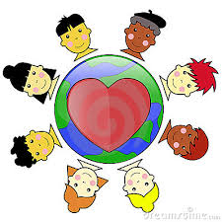
Cultural Celebrations

Special Food | Special Clothing | Special Activities
________________________

_______________________________________________

Would You Rather…. (circle your personal preference)

Have a dog or cat?
Eat broccoli or carrots?
Eat cheese pizza or Hawaiian pizza?
Meet Justin Trudeau or Justin Bieber?
Eat fries with or without ketchup?
Go swimming or skating?
Be outside in snow or sunshine?
Play indoors or outdoors?
Go to a beach or a park?
Drink something hot or something cold?
Be an artist or an athlete?
Now share and compare with a partner!

We both prefer______________________________________________________

But I ________________________________________________________________
and he/she ____________________________________________________________________

Sleep in a tent or a hotel?
Watch TV show or YouTube?
Lego or video game?
Read a book or watch a movie?
Be in a room with a spider or a snake?
Play basketball or hockey?
Eat a bag of chips or a chocolate bar?
Go Sky diving or bungee jumping?
Have the ability to fly or become invisible?
Be with friends or be alone?
Play basketball or hockey?
My Community and Me!
Draw a picture of yourself inside the small circle. In the outside circle, draw, label and color places in your community.

My Community Helps Me….  Choose a place in your community you visit often. How does this place help you? | I Help My Community …  Choose one thing you can do to help your community. Draw and write how you will do this.
My Community and Me (part 2)
Exploring Global Justice

Title:  __________________________________________  Author:  _________________________________________  Country:  __________________________________________  Main Character:  _________________________________________  Global Issue:  _________________________________________ | Summary….
I’m wondering… | This reminds me of ….
I’m visualizing …

Important historical facts I learned…

Reflection …. (Reaction, response, feelings, opinions… how this story connects to global justice)

