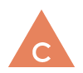
Communication

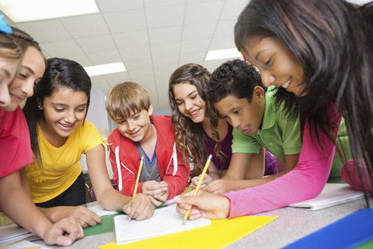

I can listen to and contribute ideas in conversations.
I can present my ideas clearly in an organized way.
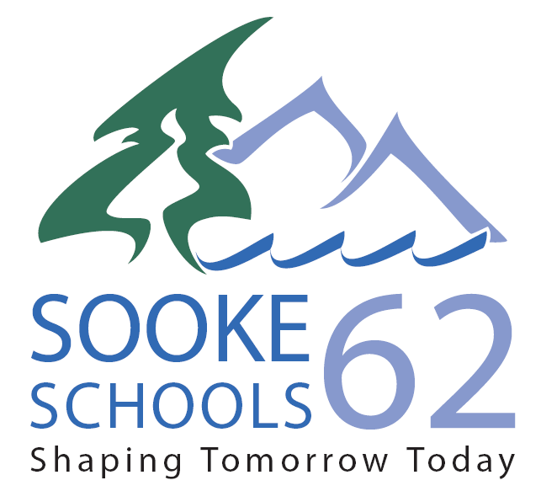
I can work with others to carry out a group goal.
I can reflect on my learning.
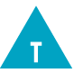
Creative Thinking 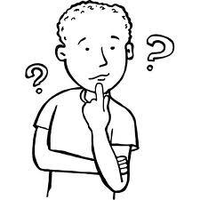

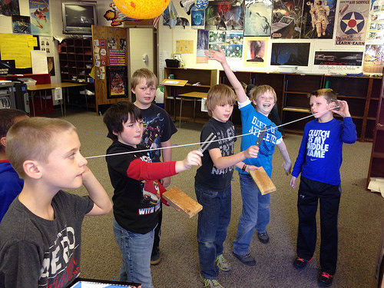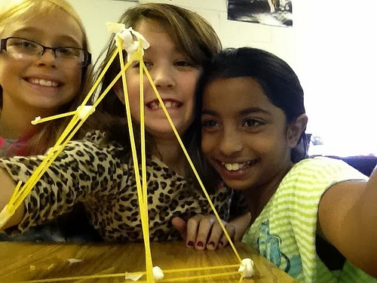

I can get new ideas and build on other’s ideas to create new things.
I keep working with ideas, and sometimes it takes a few tries.
Critical Thinking

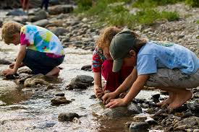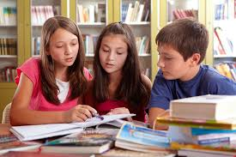

I can explore and ask questions to pursue my curiosities.
I can use criteria and evidence to make judgments.
I can develop and design different approaches and solutions.

Positive Personal & Cultural Identity

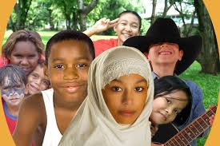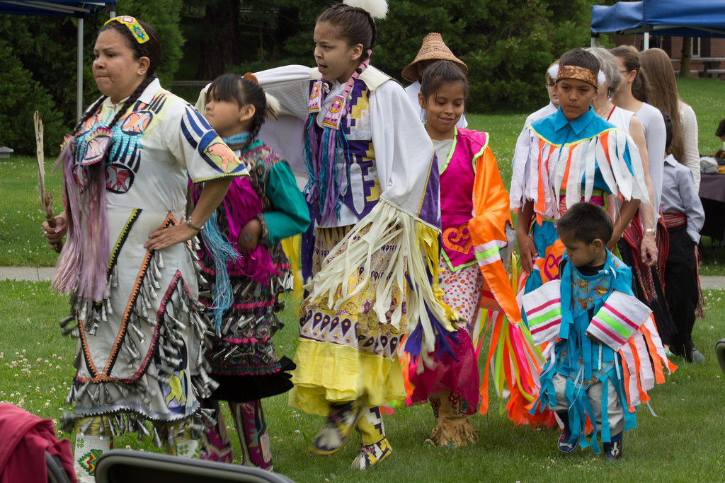

I can describe who I am, and my positive qualities and strengths.
I can make choices based on what I value.
I can explain how belonging to different groups helps me learn about myself.
Personal Awareness & Responsibility

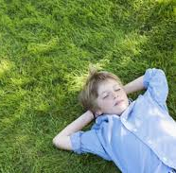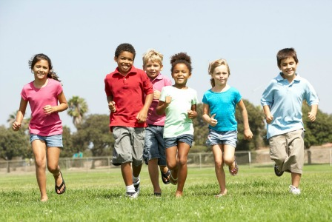

I can set goals, develop plans, and celebrate my growth.
I recognize my feelings and use strategies to handle difficult times.
I can make choices that keep me happy, healthy, and safe.

Social Responsibility

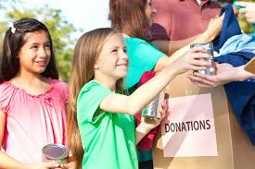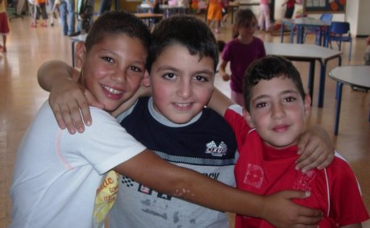

I can show respect, kindness, and support to others.
I appreciate others’ ideas and can stand up for what’s right and fair.
I can use strategies to solve problems in peaceful ways.
I can contribute to my community and care for my environment.

