** Communication**

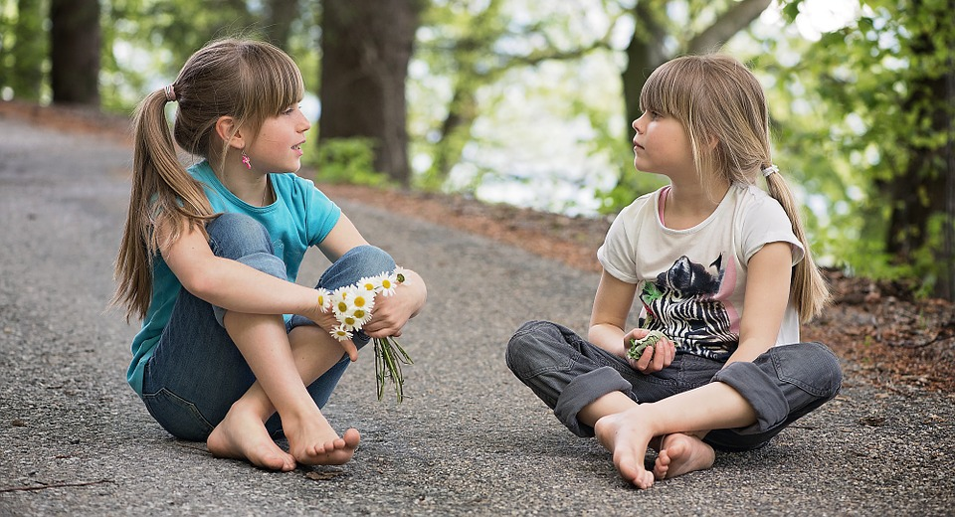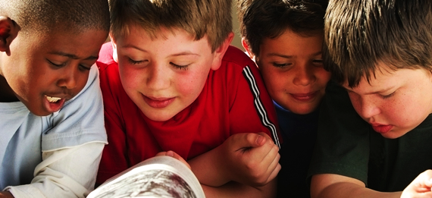

I can share my ideas and questions.

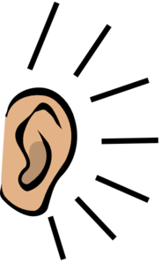I can listen to others.

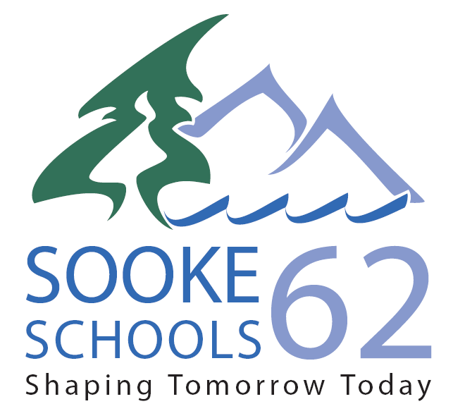

** Creative Thinking**

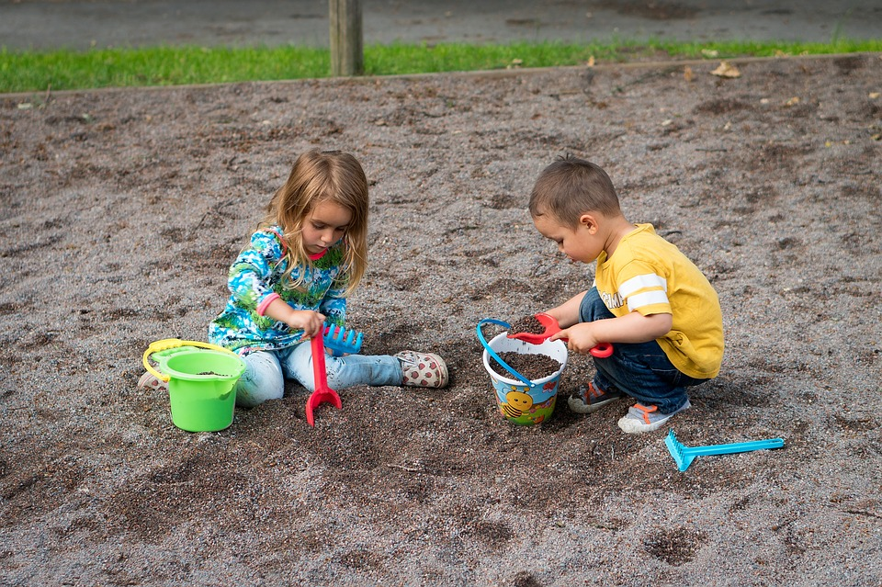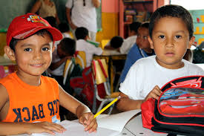

I get ideas when I play and explore.

I try a new idea when something doesn’t work.

** Critical Thinking**

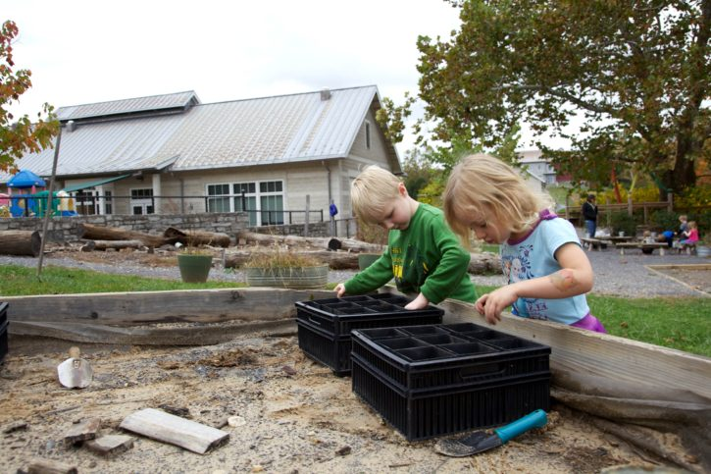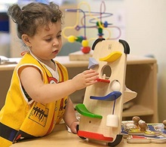

I get ideas when I use my senses to explore.

I can try different ways of doing things.

**Positive Personal & Cultural Identity**

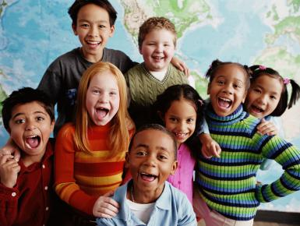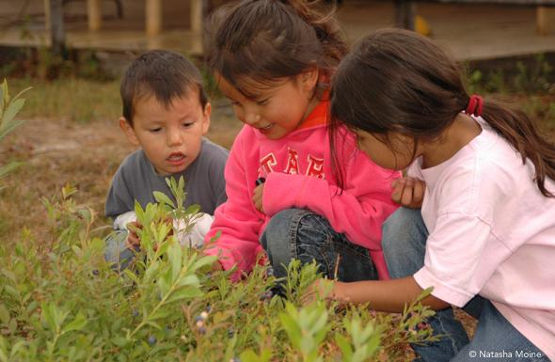

I know who I am and some special things about me.

I can tell you about the people, places, and things that are important to me.

**Personal Awareness & Responsibility**

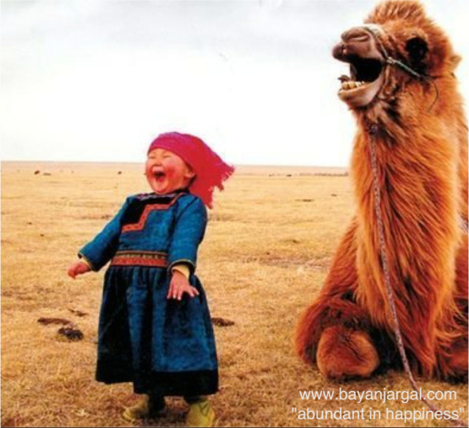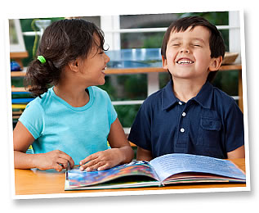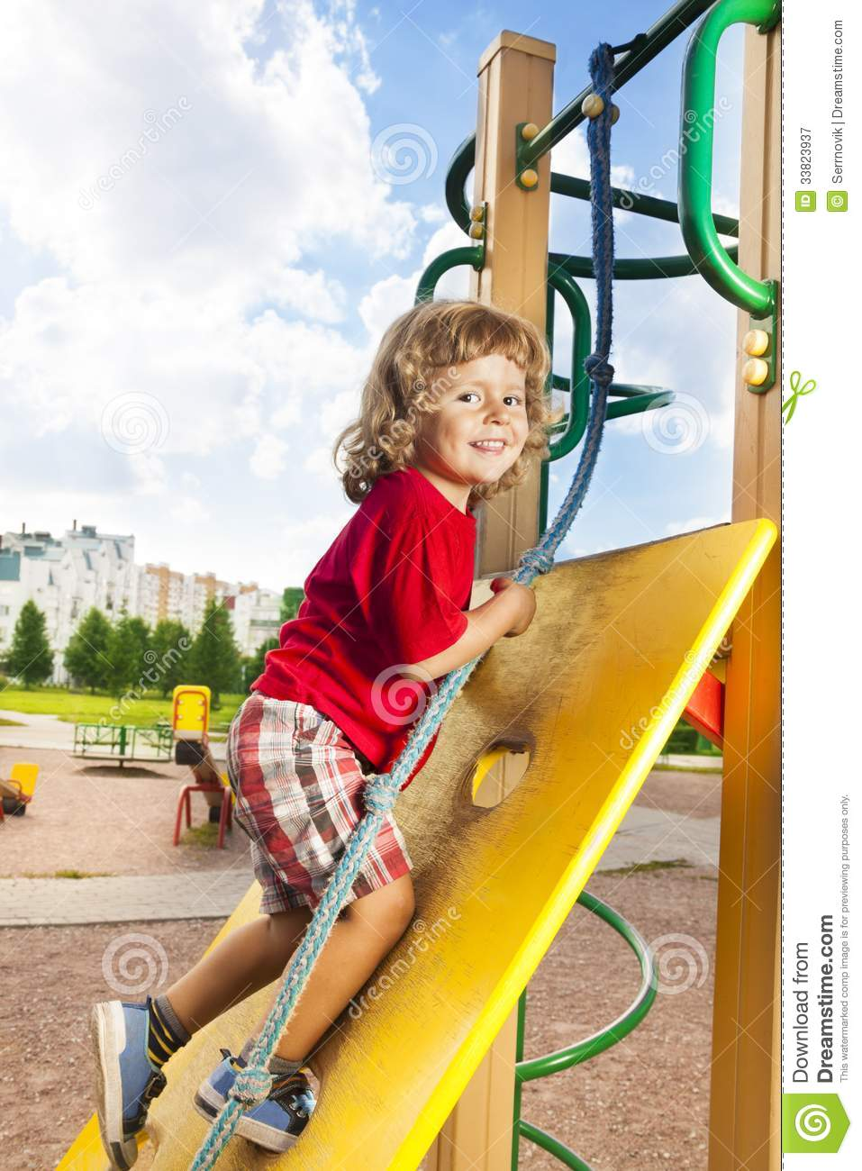

I can share my feelings.

I try to make decisions that keep me happy and safe.

 **Social Responsibility**

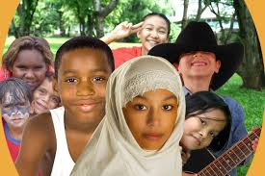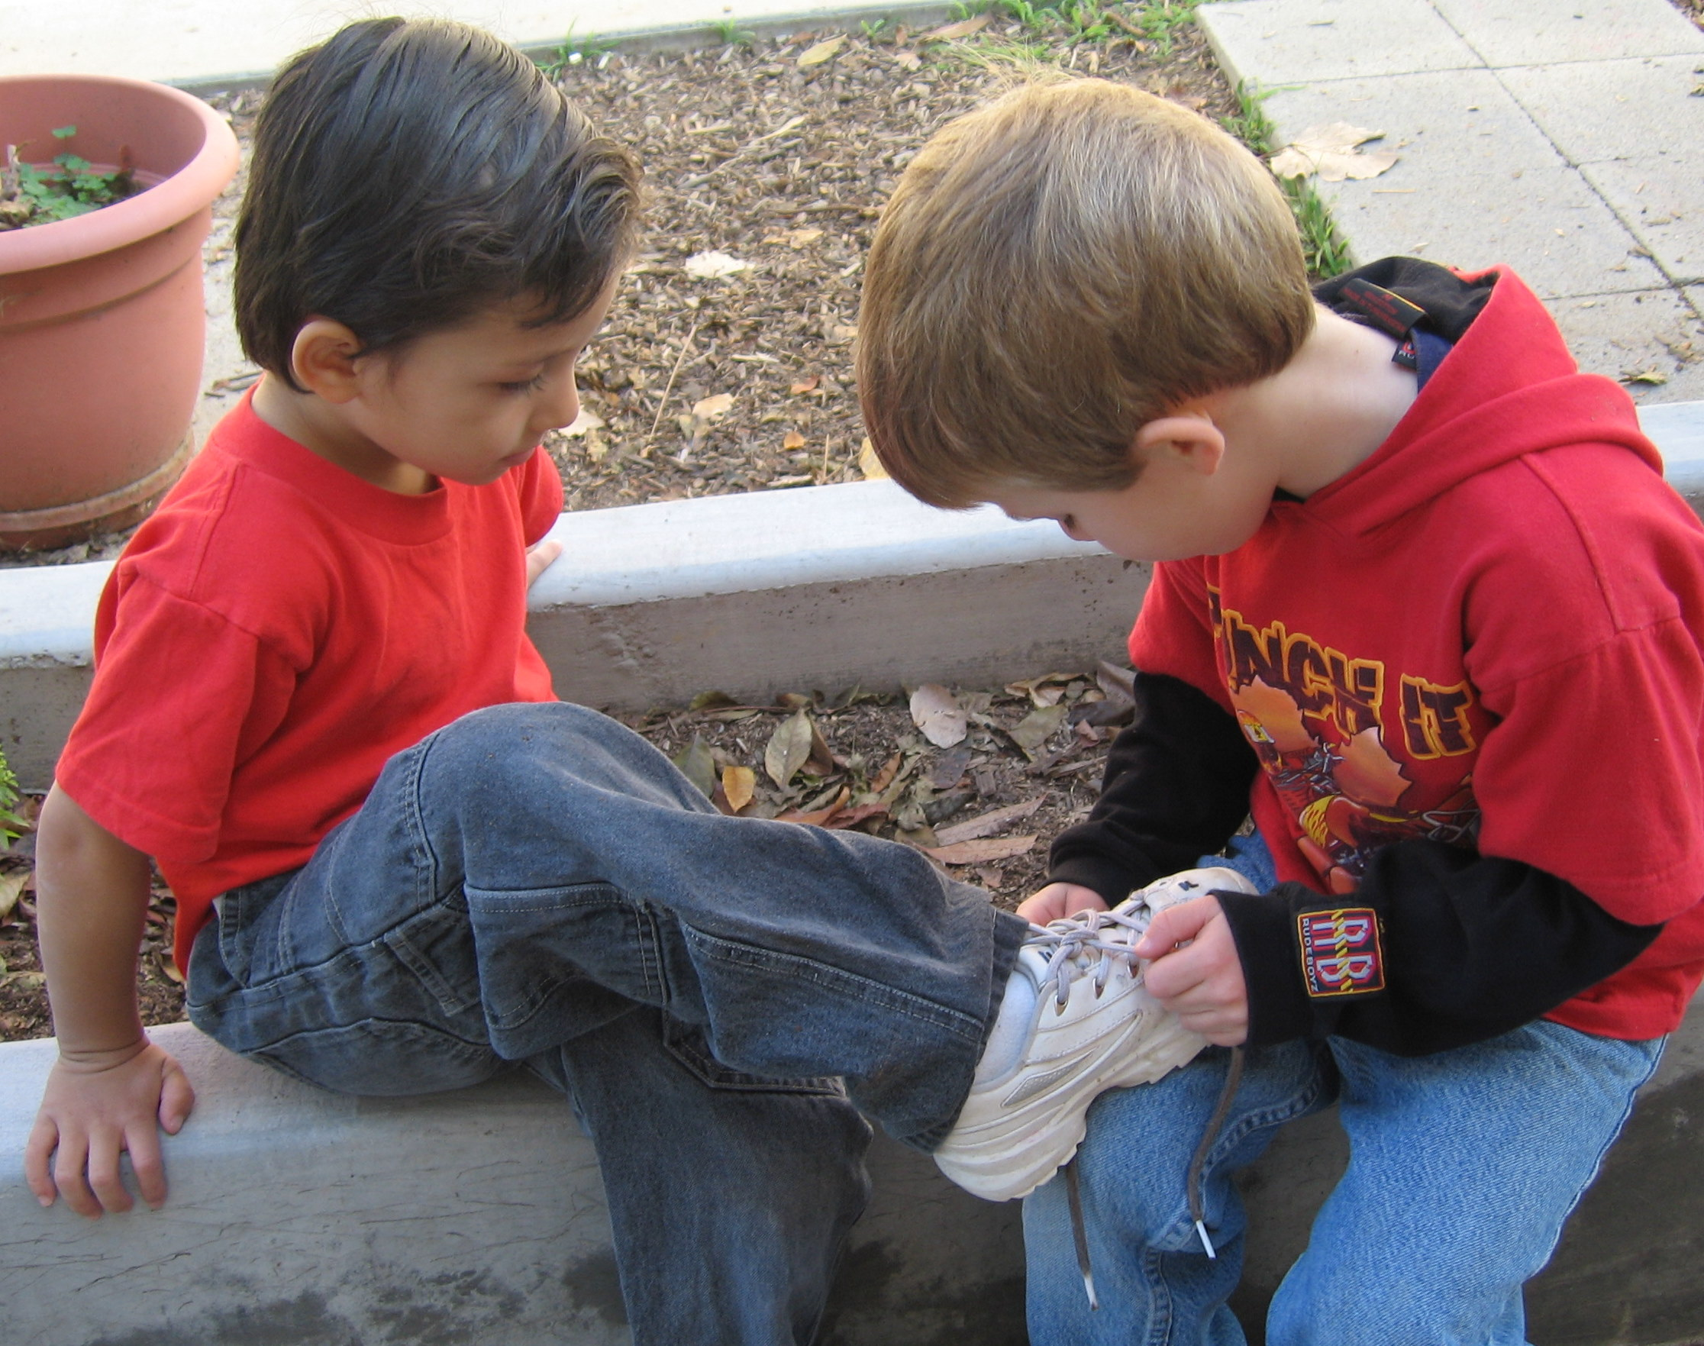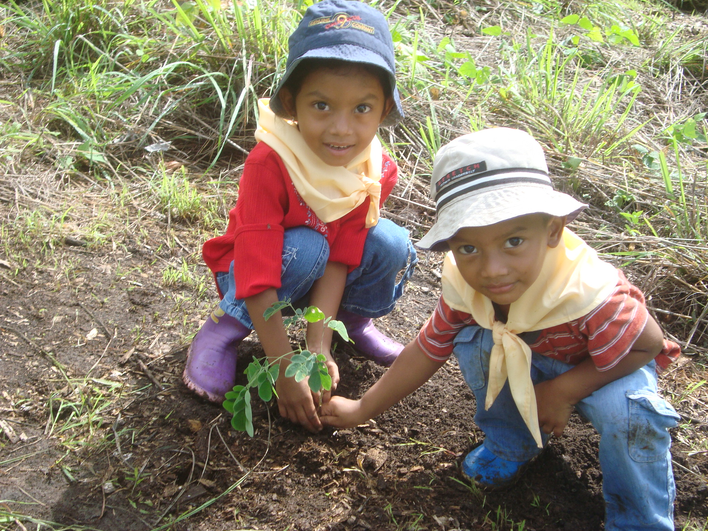

I know that other people can be different from me.

I can solve some problems and ask for help when I need it.

I am kind to others and our environment.