Apple iPad Apps
for Kindergarten and Grade One
Updated in January, 2012

Teach Me: Toddler
(counting, letter/number recognition, shapes, letter sounds, colours)
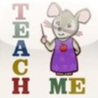 | Teach Me: Kindergarten  (sight words, addition, subtraction, letter sounds)
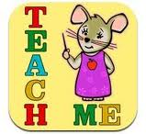 | Teach Me: First Grade  (sight words, spelling, printing, addition subtraction)
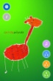 | iWrite Words  (letter/number formation)
 | iTot Cards  (various flash cards)
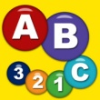 | Preschool Connect The Dots Game  (sequencing letters and numbers)
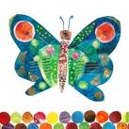 | My Very First App – Eric Carle  (colour/ picture memory game)
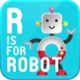 | Interactive Alphabet  (letters, letter sounds)
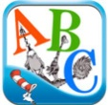 | Dr. Seuss’s ABC  (interactive audio story)
 | Intro to Letters by Montessorium  (letter recognition, letter sounds, letter formation)
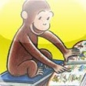 | Curious George’s Dictionary  (interactive picture dictionary)
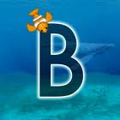 | Letter Writer: Oceans  (upper case letter formation)
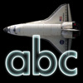 | Letter Writer: Space  (lower case letter formation)
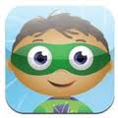 | Super Why!  (letter recognition, rhyming, letter formation)
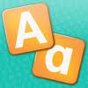 | First Letters  (letter recognition)
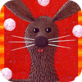 | Animal Alphabet  (letter recognition, letter sounds, animal facts)
 | Alphabetty  (letter recognition, letter sounds, animal facts)
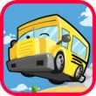 | Alphabet Car  (letter recognition, spelling)
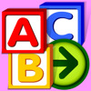 | Starfall  (letter recognition, letter sounds)
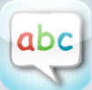 | ABC Pocket Phonics  (phonics, letter/number formation)
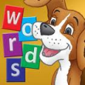 | First Words with Phonics  (phonics, blending sounds)
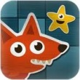 | AlphaWriter by Montessorium  (phonics, blending sounds)
 | Word Magic  (letter sounds)
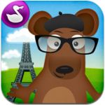 | Word Wagon  (Dolch sight words, letter recognition, letter sounds, spelling)
 | Build A Word  (letter recognition, spelling)
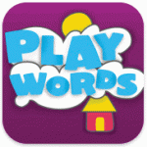 | Playwords  (letter sounds, spelling)
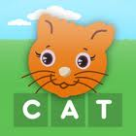 | First Words  (letter recognition, spelling)
 | All Sight Words  (Dolch sight words practice)
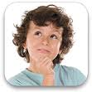 | Kindergarten.com What Rhymes?  (rhyming)
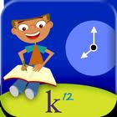 | Timed Reading  (reading fluency practice)
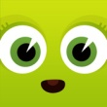 | ABC by Paul McDougall  (alphabet book without audio)
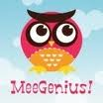 | MeeGenius! Bookshelf  (stories with audio)
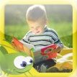 | I like books  (37 picture books with audio)
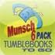 | Tumble Books To Go: Munsch 6 Pack  (6 Robert Munsch stories with audio)
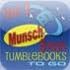 | Tumble Books To Go: Munsch 5 Pack  (5 Robert Munsch stories with audio)
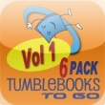 | Tumble Books To Go  (stories with audio)
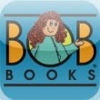 | Bob Books Magic  (interactive phonics books)
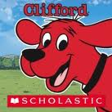 | Go, Clifford, Go!  (interactive story with audio)
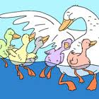 | 5 Little Ducks  (interactive story/song with audio)  *Many other story and songs can be found from the seller, Perplext.
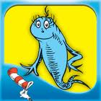 | One Fish, Two Fish  (interactive story with audio)
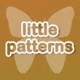 | Little Patterns for Kids  (extending patterns)
 | Monkey Rows Patterning  (extending patterns)
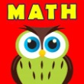 | Kids Math Ace  (addition, subtraction)
 | Approach to Montessori – Numbers  (number formation, recognition, quantity, and sequencing)
 | Tom and Tao in Numberland  (number recognition, quantity, formation)
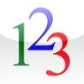 | Toddler Counting  (counting)
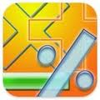 | Basic Math  (drill and practice, addition, subtraction, multiplication, division)
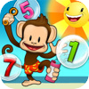 | MonkeyMath  (counting, addition, subtraction, less/more, sorting, shapes, patterns, number recognition and formation, sequencing)
 | Park Math  (counting, addition, subtraction, less/more, patterns, sorting)
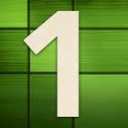 | Intro to Numbers by Montessorium  (number recognition, sequencing, odd/even)
 | Wood Puzzle  (24 different puzzles)
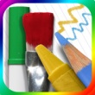 | Drawing Pad  (mobile art studio)
 | Learning to Draw is Fun  (guided drawing)
 | Doodle Buddy  (doodle sketch pad)
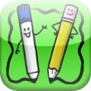 | Light Board  (guided drawing)
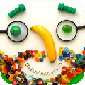 | iMake Faces  (create collages using pictures of everyday objects)
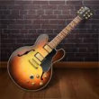 | GarageBand  (mobile music recording studio)
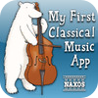 | My First Classical Music App  (introduction to classical music)

* If you have found an educational app that would be great for Kindergarten or Grade One children, we would love to hear about it. Please pass along any suggestions to cfanning@vsb.bc.ca

