Design thinking invites creatives to tinker with different approaches to notice what might wow their intended audiences. It encourages writers to translate their works through different mediums/modalities creating multisensory experiences that others will find meaningful and memorable. It requires writers to consider more than words; motivating them to write for worthy purposes, to tuck well-crafted print inside of beautiful packages and to deliver it efficiently to people, they hope to influence.
The beauty of poetry is that it uses metaphor, sound symbolism to convey a story. Its purpose is to evoke emotion. More importantly, poetry is about playing with words.

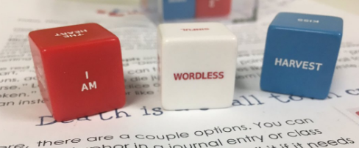
“A metaphor can be more accurately described as a strategy for talking about one thing while MEANING SOMETHING ELSE. And the way you do that is not by setting up a comparison, but by setting up an EQUATION! An equation in which you claim two things are essentially the same thing and can be interchanged.” Taylor Mali

Equipment each person: metaphor dice, post-it notes, mobile device (ipad with Voice Record Pro), online platform (student blogfolio, website, OneDrive)
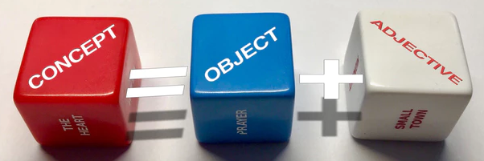

Fire Starter: How might you build a poem that invite others to experience the story?
(For the teacher: How might you document shifts in the student’s thinking, learning and work?)

Procedure:
- Take 3 dice (one of each colour: red, green and white).
- Roll the dice and take a picture of the three words (this is your starting brainstorm draft).
- Play with the words until you come up with phrases that are generated from the 3 words. Start by recording any number of ideas that might be generated. They can be as outlandish as whatever pops in your head. (*Using post-its may help to move ideas around or use strips of paper.)
- Weave these ideas together by saying them and filling them in with other ideas that pop in your head. (*You might use an ipad with Voice Record Pro to record some of your drafts.)
- Write your story. Poetry is meant to be spoken not statically sit on a page. Read and record your voice. Self-assess: what parts do you like; what is still missing?
- Record your final piece.
- Upload both the picture you took at the beginning and the sound recording to a digital platform for sharing (student blogfolio, website, OneDrive).

Communicating Student Learning:
Documenting Action…
Does it…  - Support growth?  - Move learning forward?  - Tell a story about the learning? | Does it…  - Encourage reflection and metacognition?  - Make meaningful connections to future learning?  - Support focused collection through curation?

Example using LOVE IS, FALLING, DOG:
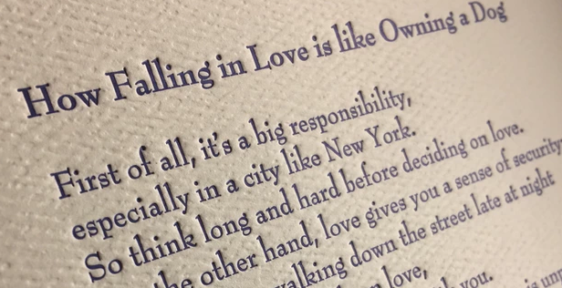

Make your own:
Major Concept nouns (red) | Noun blue/green | Adjective (white
MY TEACHER | BULLSEYE | BEAUTIFUL
POETRY | MIRROR | MAD
LOVE | HANDED-DOWN | BLESSING
FAILURE | BACK-HANDED | WONDER
CANADA | GENIUS | STABLE
THE FUTURE | SILENT | PROMISE
YOUR MOTHER | SMALL TOWN | ZOO
THE FUTURE | CHAOS | FLEXIBLE
MY SOUL | UNRULY | ACT
THE PAST | UNOFFICIAL | APOLOGETIC
HAPPINESS | MAD | UNOFFICIAL
I AM | IMPOSSIBLE | BROKEN
THE WORLD | RUGGED | BURNING
YOUR BODY | MIRROR | SACRED
MY SOUL | PROMISE | SILENT
MY FATHER | BLESSING | GENTLE
MY MOTHER | UNSPOKEN | SAD
POWER | CITY | HAPPY
HOPE | DOG | BRIGHT
GRIEF | CAT | SILENT
SADNESS | THUNDERSTORM | UNRULY
TIME | SONG BIRD | WICKED
HOME | SUPER HERO | BEAUTIFUL
THE HEART | BLESSING | CURSE
THE WORDLESS | MEADOW | SAD
WEDDING | PARTY CLOWN | DIVIDED
ACT | SIDE SHOW | EXQUISITE
I WAS | ZOO | ARTIFICIAL
MY HEART IS A | MIRROR | HANDED DOWN
HAPPINESS IS A | GAME | MIDNIGHT
LOVE IS A | THUNDERSTORM | DESPERATE
SADNESS IS A | SNOWSTORM | PERSPECTIVE
THE MIND | MIND | MIRROR
THE MIND IS A | PRAYER | LIKE OWNING A
GROWTH MINDSET | TEDDY BEAR | MIDNIGHT
CRITICAL THINKING | SONG BIRD | UNSPOKEN
COURAGE | CAGE | JOYOUS
CHANGE IS | PERSPECTIVE | BEAUTY
FAIRNESS IS | MYTH | CLEVER
JUSTICE | IDEA | COOL
SURVIVIAL | BEAUTY | HAPPY
PERSPECTIVE | PATTERN | JOYFUL
CONFLICT | EMPATHY | MIRROR
EXPLORATION | CULTURE | VISUAL
MYTH | VOICE | FANTASTIC
IDEA | CYCLE | COLOUR
FANTASY | BIRDS | WONDER
COMMUNICATION | ROUTINE | RUGGED
RELATIONSHIP IS | ACTION | SILENT
MIGRATION | SEASON | SOFT
I CAN | CURSE | QUIET
HISTORY IS | HEART | QUESTION
SUCCESS IS | STRAIGHT | WHISPER
GROWTH IS | HOUSE | FAINT
THE WORLD | POET | STRETCH
MY LIFE | PROMISE | LIKE HAVING A
MY FAMILY | ELEPHANT | CHILL
WORDS | SHADOW | RELUCTANT
TRUTH | ANIMAL | DIVIDED
BEAUTY | THUNDER STORY | SPELL-BOUND
MEMORY IS | BRAND NEW TOY | BURNING
HOME | KISS | BRILLIANT
LIFE IS | HAZARD | DARK
LIFE | TREES | HAZARD
LOVING YOU | BEES | HEARTY
LOSS | BIG CITY | RANDOM
MY BIRTH | SHRINE | REBUFF
MEMORY IS THE | SKY | SHINY
DESIGN IS | TRAGEDY | SPELL-BOUND
KIDS TODAY | SHRINE | MIDNIGHT
STORY IS | HARVEST | SIMPLE
WORDS ARE | SIDEWALK | WORDLESS
FREEDOM | STORY | UNSUNG
LEARNING IS | TECHNOLOGY | OLD
MY TEACHER | LIFE-CHANGING | DAYLIGHT
LEADERS ARE | GARDEN | LIGHT
CULTURE | TOY BOX | AWESOME
TECHNOLOGY | IDEA | SPARK
TODAY | HOLIDAY | SMOKY
DIVERSITY IS | WORD | GRATEFUL

