*NOTE: While this is in a table format, you can edit/delete and choose one area of the core competencies to focus and share.

CORE COMPETENCIES
Communication
Creative Thinking
Critical Thinking
Personal/Social

Snapshots of My Learning  (insert photo/image here)  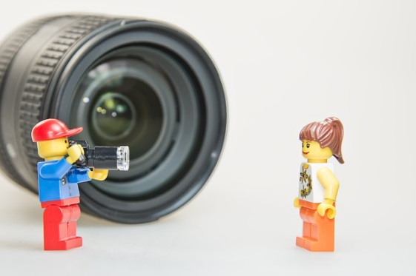  Before I used to think/do …  Now I … |  | (insert photo/image here)  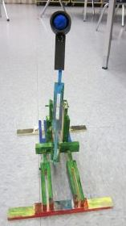  Record “I can” that reflect…  Eg. “I can redo my design…”  Eg. “I can persevere to finish…”  Strengths:  I feel I was really good at …  I want you to notice … |  | (insert photo/image here)  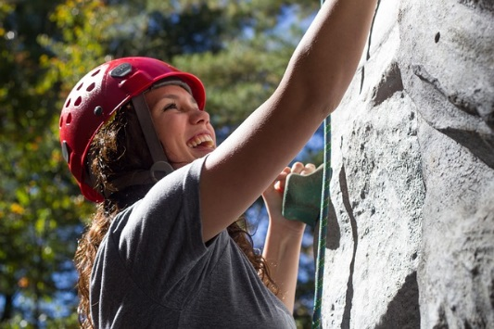  Stretches:  If I could change one thing, it would be …  because …

