CORE COMPETENCIES (*threaded throughout the curriculum)
Communication  - I recognize that there are different points-of-view and I can disagree respectfully.  - I can work with others to achieve a common goal |  | Creative Thinking  - I can build on ideas or combine other people’s ideas in new ways to create new things  Critical Thinking  - I can evaluate the credibility of sources of information. |  | Social Responsibility  - I contribute to group activities that make my classroom, school, community, or natural world a better place.  Positive Personal and Cultural Identity  - I contribute to group activities that make my classroom, school, community, or natural world a better place.
As Readers and Authors, we are exploring story (using a variety of genre) to help us understand ourselves and make connections to others and the world. Playing with language enables us to communicate our thinking. This includes using an organized process to plan, develop and create engaging and meaningful products aimed at specific audiences.  As Speakers and Listeners, we are developing our ability to exchange ideas and viewpoints to build and extend thinking.  As Mathematicians, we are exploring the concepts of parts and wholes of numbers through the relationships between decimals, fractions and percents. This flexibility with numbers extend to operations with integers. We use logic and patterns to solve puzzles. This in turn develops our mental math strategies. |  | Name of school Elementary  Grade 7 (Term 1)  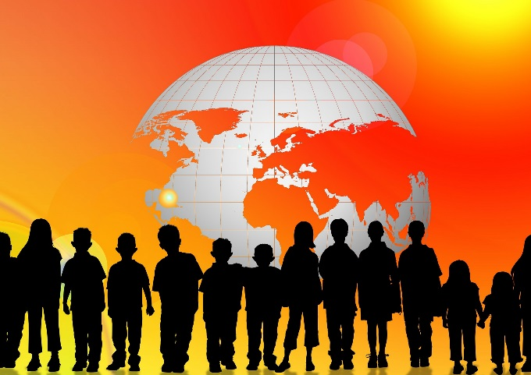  Teacher Name  As Citizens, we are accessing inquiry processes and use critical thinking skills to gather, interpret and analyze ideas. We recognize that there are many conditions that impact and shape the development of a culture and society throughout history. |  | As Scientists, we are inquiring about what enables all living things to adapt and survive in their environment. In turn, these observable changes affect the biodiversity of our planet. We continue to design experiments to develop the skills of questioning, hypothesis and prediction, planning and conducting.  As Artists, we are creating art to express ourselves (feelings, ideas, and experiences).  Principles of design are explored as we apply variety of materials, movements and appropriate technologies to create products.  As Athletes, we are participating in daily physical activities that influence our physical literacy and personal health and fitness goals.  As Designers and Makers, we are forming ideas (ideating) that design can be responsive to identified needs. We explore a variety of tools to create prototypes and redevelop them create new designs.

