Using KDU
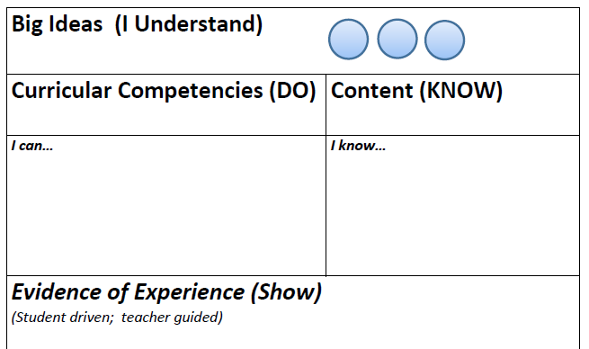
Use what you KNOW to DO something real (through activities/strategies/skills).
Your “evidence of the experience” SHOWS what you UNDERSTAND.

Big Ideas (I Understand)

Curricular Competencies (DO) | Content (KNOW)
I can… | I know…
Evidence of Experience (Show)
(Student driven; teacher guided)

