RETELLING HELP

Think First.
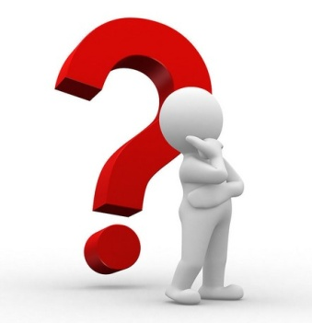

Fiction | Non-fiction
- Beginning  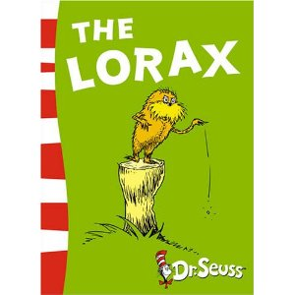  - Middle  - End  - Where?  - Who?  - What was the problem?  - How was it solved? | - Ideas that support the main idea  - Summarize what was read  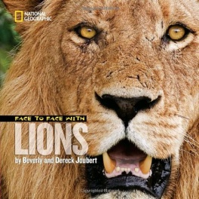  - Key vocabulary from the text

