Writing Support – Speaking as Typing

You can use the Speak as Typing option to support writing. In Tools, select Options.

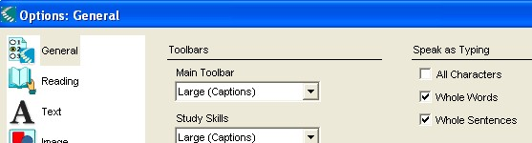

Select Whole Words, Whole Sentences – will provide auditory support as you type.

Word Prediction Dictionary

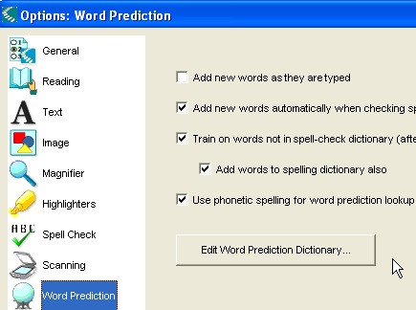
Word prediction can be used to increase support in writing.

In Tools > Options, select Word Prediction.

Select Use phonetic spelling for word prediction lookup. (*This will provide the greatest support for the student.)

The others are optional and will depend on the individual needs of the student. Each level can be selected at any given time.

Click on Edit Word Prediction Dictionary to change the starter list.

Word Prediction Dictionary cont.
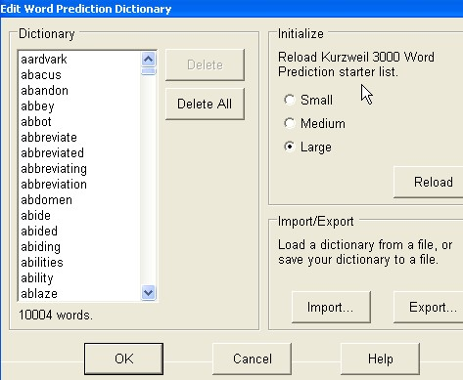

A starter list is provided (grouped in small, medium, large). You can import/export a Kurzweil word prediction file and it will replace the starter list.

(*Note: If you RELOAD a starter list, it will delete all personally added words.)

Using Word Prediction
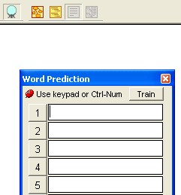
Open up a new document by clicking FILE > NEW.

Click on Word Prediction icon (on writing toolbar).
This will open up the Word Prediction popup.

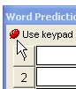
You can pin the tool to your writing so that it follows the cursor of your writing.
To do this, mouse over the pushpin and click it.

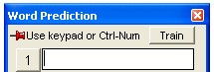

The pin will change to a side pin.

Word Prediction cont.

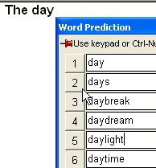
Start typing and you will see Word Prediction follow you with suggestions.

Scan the list to find the correct spelling.

To select the word, use Control key + Number OR click the number OR double click the word to insert the word.

Changing Text Size or Number of Words in List
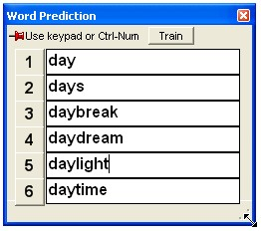

To change the size of the words or the number of word options, move your mouse to the lower right corner.

Hold mouse down until you see the double arrow and drag it diagonally.

Training Word Prediction to Add Words

Training words is a two-step process.

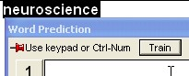
Type the word you wish – highlight it and click Train.

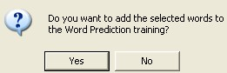
Click Yes to add.

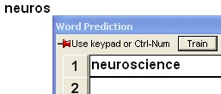
When you retype the word or continue typing, the new word will show up in your Word Prediction.
Create Custom Vocabulary Lists

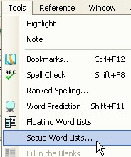

In Tools > select Setup Word Lists.

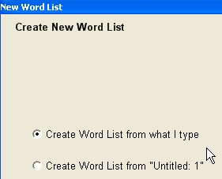

To create your own list, click Create Word List from what I type.

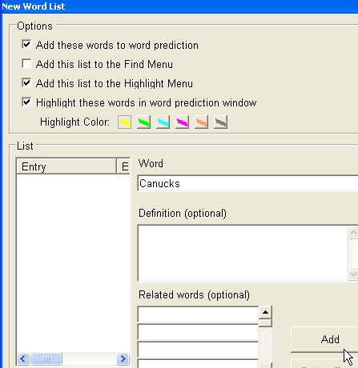
In Options, select:
- Add words to word prediction,
- Add to Highlight Menu,
- Highlight words (select colour that it will pop up in word prediction window.

Type in the word you wish.

Click Add.

Create Custom Vocabulary Lists cont.
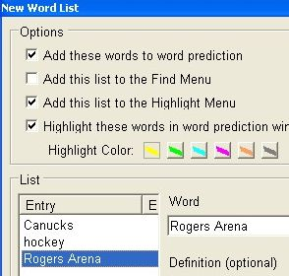

Your New Word List will be listed under Entry.

When complete, click Next >>

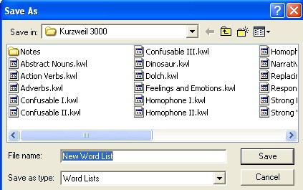

Name your New Word List with a title. (In this example, we used ‘Canucks’.

Choose a location that is accessible to your students to save the file.

(*Note: Consider if you are using a Lessons drive or home drives or a usb drive for student work.)
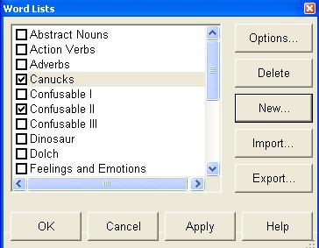

Our new word list (eg. Canucks) is listed in the Word Lists area.

All of the word lists have options to add or delete.

