THM Design Co.
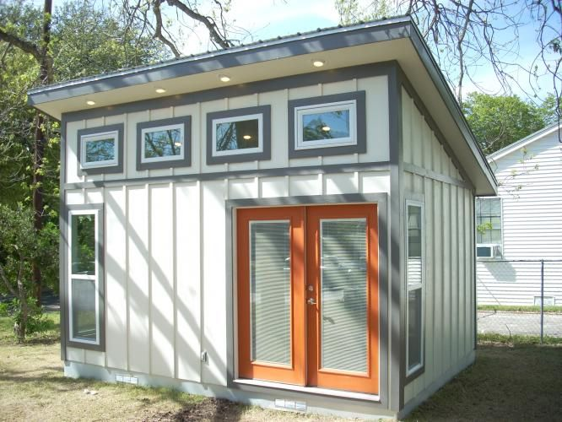
Building Plan: Week 4
Building the Prototype!

Creating the walls:
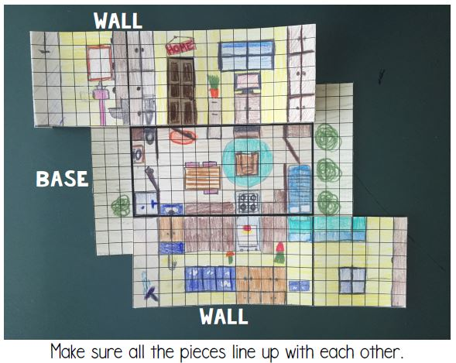
With your floorplan chosen by your client(s), it is now time to work on the prototype and for this we need to design the walls. The 4 walls will also need to be to scale, so continue to use the same scale as your floorplan. Remember your height restriction is 10 feet! Each item you placed in the floorplan will now have height. For example: kitchen cabinets are approximately 36 inches from the ground, so your cabinets will need to come 36 inches up the wall(s). Here is a guide to help you:
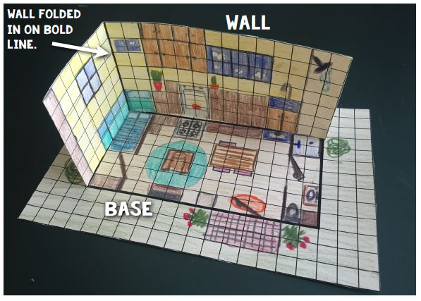
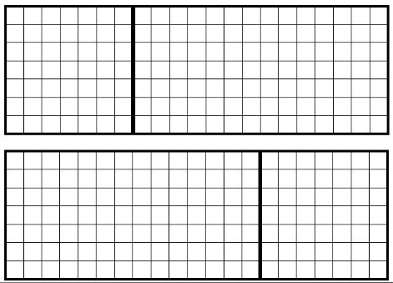

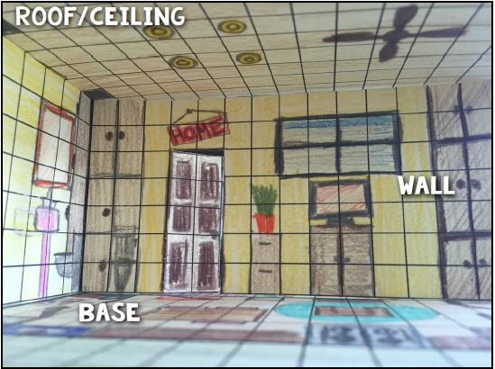
Creating the ceiling:
A ceiling, or more than one ceiling if you have a loft will also need to be created to scale. Does your ceiling follow the same slope of your roof or is it level inside? Does your ceiling have light fixtures, pot lights, ceiling fans, skylights, railings for lofts, etc.? How can you make your ceiling/roof come off so the client can see inside the tiny house prototype?
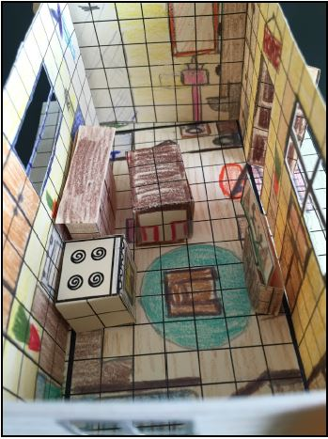
Adding 3D elements to the space:
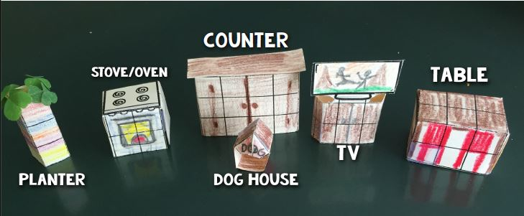
To get a better feeling of being in the space, try to incorporate some 3D elements. Remember, even in 3D, these all need to be to scale.

