THM Design Co.

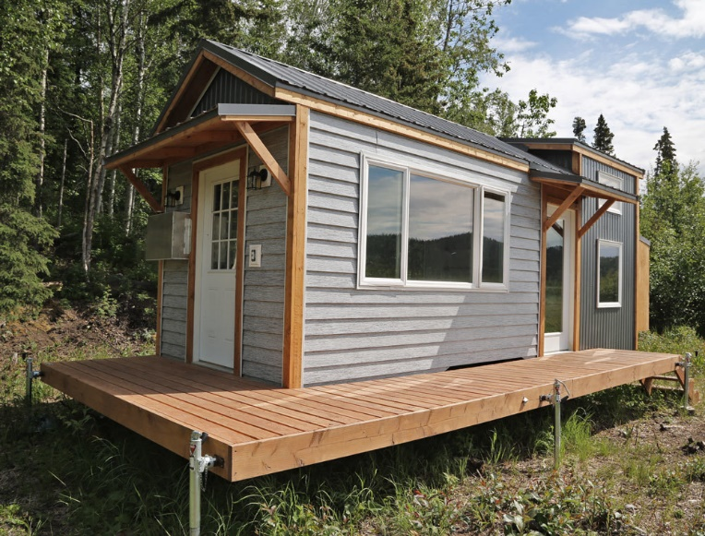
Building Plan: Week 3
Attend the Consulting Meeting!

Good Copy of 2 Floorplans:
Work on a good copy of both floorplans, taking into consideration any feedback and answers to your questions you received at the consulting meeting this week. Be sure to have the scale marked clearly on your drawings.

Double Check the Budget:
Go through the budget carefully. Are there items or things that change from one plan to the other that you may need to point out to the client in terms of how it may affect price.

Be Ready to Present:
When you are finished your floorplans, please send them to the CEO to share at the next meeting with the client(s). You can send them as documents, scans or photos. You may want to check that they are easily read. It is suggested that you use a fine liner so the details show up better.

