IN-CLASS ACTIVITY: STRESS AND THE BRAIN (DURING PERIOD 3 anytime)

Intention of the Lesson:

To learn about different parts of the brain and how we can regulate stress.

All materials will be available in teacher letter trays on Tuesday, May 3rd

Part 1: Understanding the Brain (35 minutes)

Step 1: Class Brainstorm (2-3 minutes)

Ask students, “What makes you feel stressed?”

Make a list on the board

Remind students we all feel stress!

Step 2: Brain Jigsaw Activity (20-30 minutes)

Teacher instructions:
- Divide the class into 3 large groups.
- 1/3 of the class – Amygdala
- 1/3 of the class – Hippocampus
- 1/3 of the class – Pre-Frontal Cortex
Then, divide each group into groups of 3-4.
Provide each group of 3–4 with a Brain Anatomy fact sheet (found in this package)
- Instruct students to read the fact sheet and become the experts on their section of the brain (amygdala, hippocampus, or Pre-Frontal Cortex (PFC)

- Students create a poster about their section of the brain.
- Hand out 11 x 17” paper to each group of 3-4

  - Students share the information learned from the fact sheets and design a poster:
    - Draw a picture of this part of the brain or a representation of it
      - Ex. a guard dog for the amygdala, elephant for the hippocampus, or wise owl for the PFC
    - Describe the function of your part of the brain in times of stress
    - Include a few words or short sentence about how that section responds in times of stress.
  - Invite students to share their poster
Teachers collect posters that students would like to have posted in common areas of the school. This is optional but encouraged.

Part 2: Strategy to Manage Stress – Deep Breathing
(5 minutes)
Teacher reads the script:

  - Imagine I told you that we have a pop quiz today, and you hadn’t studied. How would you feel? Nervous? Anxious? Maybe stressed? Let’s try deep breathing now and see if we notice any change in how we feel.
  - This is an invitation. If you are not comfortable at any time, simply notice how you are feeling, and gently focus on your hands in your lap until your classmates are finished.
  - We are going to take three deep, slow breaths to activate our parasympathetic nervous system. This is the system of the body that produces calm and relaxation.
  - This system is activated when you breathe in deeply through your nose and slowly exhale out of your nose or mouth.
  - So, try your best not to to breathe in through your mouth—mouth breathing has the opposite effect and may raise stress in your body!
  - Try your best to breathe in through your nose and lengthen your exhale.

Begin by inviting students to sit upright, with their hands resting gently on their desks or their laps.

Option 1: Breathing Script

- Sit in a comfortable, upright position so that you have space to breathe deeply.
- I invite you to please gently close your eyes or gaze softly down at your hands.
- You may place your hands on your belly if that is helpful.
- Now, we will take three slow breaths. As you breathe, imagine the air filling your belly and chest from the bottom to the top, as if you were filling a pitcher with water.
- Breathe in through your nose and feel your belly rise, followed by your chest.
- Now, very slowly, release the air through your nose or mouth— imagine you are pouring the water out of the pitcher. (PAUSE)
- Again, breathe in through your nose, feeling your belly rise from the bottom to the top. (PAUSE)
- And release the air, very slowly… (PAUSE)
- Once more… breathe in…
- And slowly exhale…

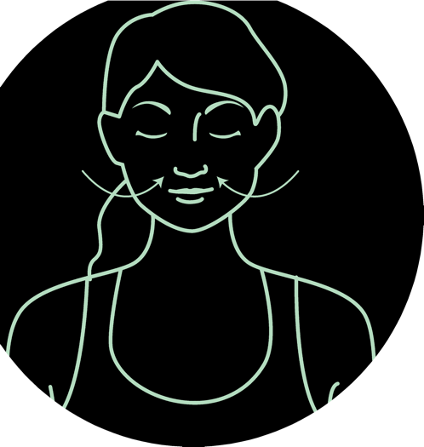
inhale exhale

Option 2 Breathing Script:
- Please note the sound of a digital chime is located on our Teams folder.

MindUp Script.

Please sit down in a comfortable position in your own personal space bubble.

I am going to invite you to show me whole body listening. Now, close your eyes. If you’re uncomfortable closing your eyes, please look down at your hands to be respectful of others around you.

Ring Chime. Wait 15 seconds.

Bring your attention to your breath.

Wait 15-30 seconds.

If your mind wanders, that’s okay. Just bring your attention back to your breath.

Wait 15-30 seconds.

Feel your tummy rising and falling.

Wait 15-30 seconds.

When you hear the chime again, listen as long as you can. When you cannot hear the sound any longer, slowly, gently, open your eyes and look to the front of the room.

Ring chime and wait for the sound to finish.

Thank you for being mindful.

End of lesson
Brain Fact Sheet – hand out to groups of 3-4
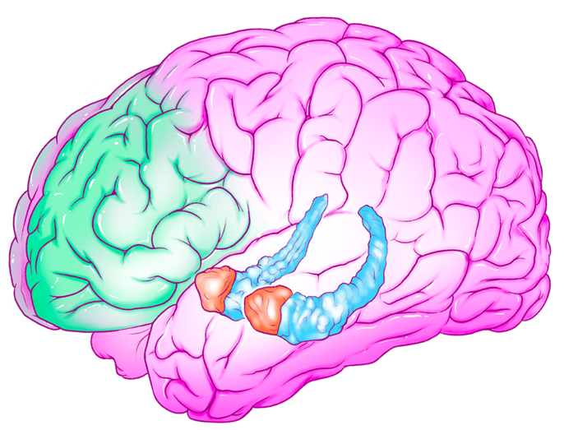
Amygdalae
Hippocampus
Prefrontal Cortex

The Prefrontal Cortex (PFC)
- The PFC is located right behind your forehead.
- It is part of the brain’s central executive network.
- This part of the brain is involved with:
- Problem solving
- Complex thoughts
- Attention and focus
- The PFC is responsible for self-control, discipline, delaying gratification, and resisting acting on our first impulse.
- The PFC can be thought of as a Wise Owl.
- The PFC helps us hold different ideas and information in mind at the same time. It helps us use the information and ideas and relate them to each other.
- It helps us think flexibly, or think in different ways about something. This is very useful for problem-solving.
- For example, if you were trying to solve a puzzle and one approach did not work, you could switch to a different strategy to get better results.
- When we are under stress, the stress hormone cortisol is produced. Cortisol impairs our working memory.
- Working memory is a cognitive system where we can hold information temporarily. It is used when we are learning new information, and holds information in mind as we are solving problems. For example, holding rules in mind as we play a game.
- An interesting fact about the human PFC is that it takes up a larger portion of the brain than in any other animal!
- Humans have an amazing ability to plan, think critically, and control our thoughts and behaviors. This is also what helps us handle complex social interactions, have empathy and help others, and cooperate with other

The Amygdala
- The amygdalae complex is located deep within the brain, in both hemispheres. That means there’s a right and left amygdala.
- It is part of the brain’s salience network.
- The salience network detects and filters salient stimuli. Salient means the most important information for survival or learning.
- The amygdala is one of the first parts of the brain to react to incoming stimuli and information.
- It helps keep us safe when we come upon danger by alerting us and making us more attentive.
- The amygdala has been thought of as your Guard Dog.
- It is the control center for our “flight, flight, or freeze” response.
- The amygdala communicates with the hippocampus to store emotional memories.
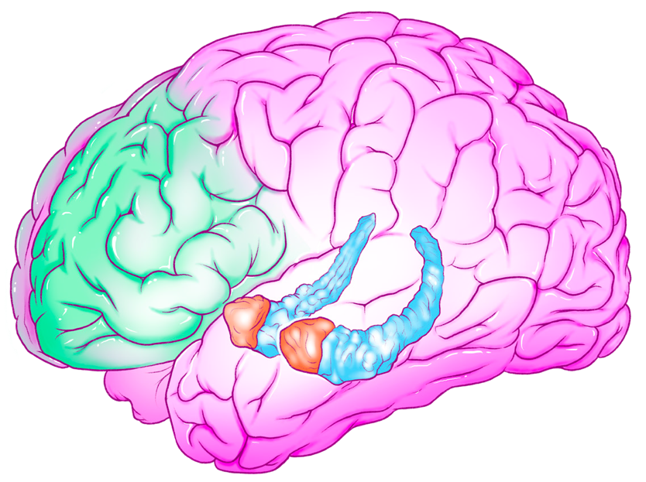
- If the amygdala triggers the stress response, the PFC prioritizes survival, and does not engage in more critical thinking
Amygdalae
Hippocampus
Prefrontal Cortex

The Hippocampus
- The hippocampus plays an important role in learning and memory.
- It was named because of its resemblance to a seahorse—it comes from
the Greek hippos, meaning “horse,” and kampos, which means “sea monster.”
- It is involved with learning and memory (storing and retrieving memories).
- The hippocampus moves new learning from working memory (in your PFC) to long-term storage in the brain.
- Working memory is a cognitive system where we can hold information temporarily. It is used when we are learning new information, and holds information in mind as we are solving problems. For example, holding rules in mind as we play a game.
- The hippocampus can be thought of as an Elephant with a great memory.
- The amygdala and hippocampus work together during emotional reactions.
- Hippocampus and health:
- Long-term stress negatively affects the hippocampus, particularly during adolescence.
- Drug and alcohol use have been shown to significantly impact the hippocampus, especially during adolescence. Changes in this brain structure due to substance abuse have been related to impaired learning and memory retention.
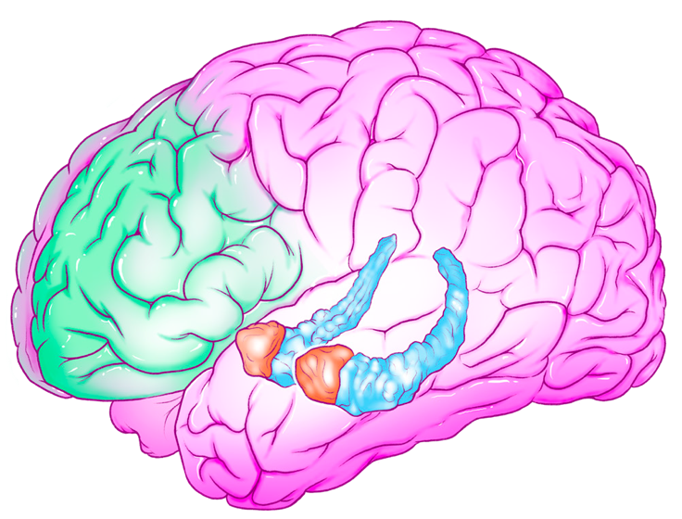
- The hippocampus is one of the first areas to suffer due to Alzheimer’s disease.

Amygdalae
Prefrontal Cortex
Hippocampus

