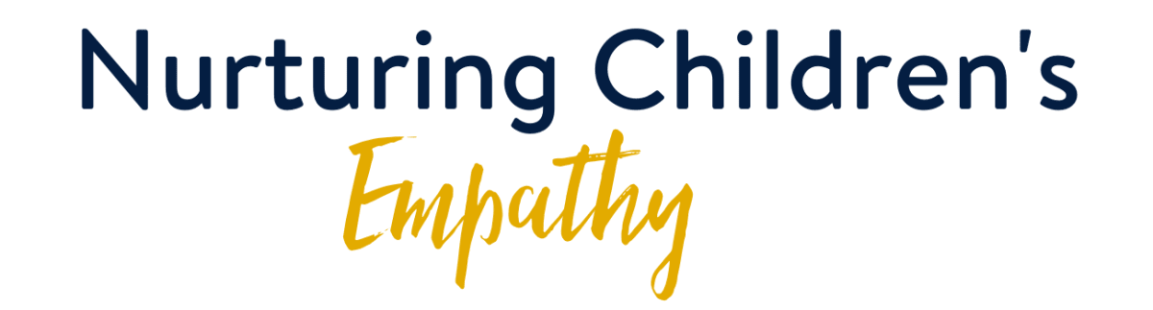

"No one is born hating another person because of the colour of his skin, or his background, or his religion. People must learn to hate, and if they can learn to hate, they can be taught to love, for love comes more naturally to the human heart than its opposite." - Nelson Mandela

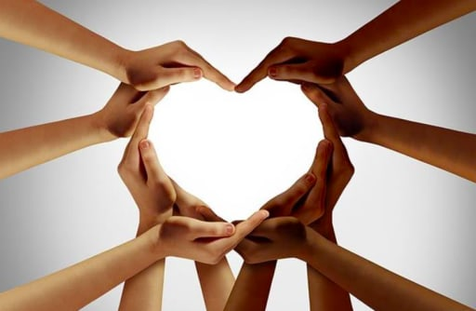
Watching our nation and the United States, it is evident that inequalities within our countries continue to exist and even thrive in parts of our society. In Canada, it is very clear indigenous populations have been marginalized, ignored, and abused with a kind of tacit acquiescence. As our conscience is awakened and our empathy stirred, it begs the question as to how we can further this empathy within our own children. We can start with the phrase, Black Lives Matter, and unpack it in the wider context of all marginalized people. Children have a highly developed sense of justice, as we all have experienced when our child is quick to point out that one ice cream cone is bigger than the other. This sense of justice can help our children grow in empathy for the mistreatment of people based on colour or ethnicity. As they are shown examples, within their capacity to handle, they can be asked questions such as:
- What would have been the right actions to take?
- How could this have been avoided?
- What do you think they were thinking in this situation?
- What would you have felt if you were the person being targeted?
- What laws could we enact that would guard the rights of all people?
These and other questions will help children identify and empathize with the concerns that are currently being raised. Children are not beyond understanding the underlying issues. In fact, it has often been the children in societies that have awakened the adults to issues that have been ignored. In order for our young children to be agents of change and healing, it must start with the empathy that we can help facilitate and not extinguish through neglect.

