https://teachrock.org/lesson/the-historical-roots-of-hip-hop/
LESSON: The Historical Roots of Hip Hop:
Grandmaster Flash and the Furious Five

** A PPT Has been created for students to follow along with the activities. All handouts have been uploaded to central’s ‘black history month’ Website.

ESSENTIAL QUESTION

What are the historical roots of Hip Hop?

OVERVIEW
Hip Hop emerged directly out of the living conditions in America’s inner cities in the 1970s, particularly the South Bronx region of New York City. As a largely white, middle-class population left urban areas for the suburbs in the 1950s and 1960s—a phenomenon known as “white flight”—the demographics of communities such as the Bronx shifted rapidly. The Bronx, one of New York City’s five “boroughs,” became populated mainly by Blacks and Hispanics, including large immigrant populations from Caribbean nations including Puerto Rico, the Dominican Republic, Jamaica, Barbados, Trinidad and Tobago, and others.

Simultaneous with the “white flight,” social and economic disruptions abounded. Construction on the Cross Bronx Expressway, which began in the postwar period and continued into the early 1970s, decimated several of the minority neighborhoods in its path; city infrastructure was allowed to crumble in the wake of budget cuts, hitting the less privileged parts of the city most directly; and strikes organized by disaffected blue-collar workers crippled the entire metropolitan area.

Amidst the higher crime and rising poverty rates that came with urban decay, young people in the South Bronx made use of limited resources to create cultural expressions that encompassed not only music, but also dance, visual art, and fashion. In music, Latin and Caribbean traditions met and mingled with the sounds of sixties and seventies Soul, Disco, and Funk. The venues for the emerging art of Hip Hop were public parks and community recreation centers, sheets of cardboard laid out on city sidewalks became dance floors, and brick walls were transformed into artists’ canvases. Turntables became laboratories for musical experimentation as old sounds were remixed in new ways. The spirit of invention was particularly vibrant against a backdrop of empty lots, boarded-up windows, and burned-out buildings.

In a borough where poverty and an eroded infrastructure meant very limited access to instruments and music education, young music makers created with what they could find. DJs assembled their own sound systems and built extensive record collections by searching secondhand stores for old Soul, Funk, and Rock and Roll albums; they used their collections to provide entertainment within their communities. Sounds taken from these records—from James Brown’s drum breaks to Parliament Funkadelic’s funky bass lines—provided the raw materials for creative work: beats to be mixed and modified. On top of that, MCs (short for Master of Ceremonies) rapped.

While early Hip Hop was often dance music, the genre also picked up where certain 70’s Soul left off, serving as a vehicle for social commentary. Stylistically, MCs drew on a number of influences, including Jamaican “toasting,” a style of lyrical chanting over a beat that was brought to New York by the burgeoning Caribbean immigrant community. The role of the MC expanded over time while the raps themselves blended influences from a variety of marginalized populations, reflecting the circumstances of an evolving urban America.
In this lesson, students will examine raw documentary footage, demographic charts, television news stories, and song lyrics to connect the sounds of early Hip Hop to the substandard living conditions in American inner cities in the late 1970s, particularly the Bronx in New York City. Students will compose their own verses to Grandmaster Flash’s “The Message,” that reflect the ricing racial and economic tensions that exist today.

OBJECTIVES
Upon completion of this lesson, students will:
- Know (knowledge):
  - How early Hip Hop reflected the social and economic conditions of America’s inner cities, particularly the Bronx in New York City
  - Important events in the history of New York City in the 1960s and 1970s, including the construction of the Cross Bronx Expressway, high crime rates, and a major transit strike
  - The contributions of early Hip Hop artists including DJ Kool Herc and Grandmaster Flash
  - Key vocabulary relating to the rise of Hip Hop, including such terms as “scratching,” “rapping,” “MC” and “DJ”
- Be able to (skills):
  - Make connections between artistic movements and the social and economic conditions from which they emerge
  - Connect song lyrics to contemporary events
  - Identify musical sources from which early Hip Hop was created
  - Students will integrate information from maps and data charts with texts and videos to make thematic connections and create deeper understandings
  - Students will apply knowledge of language to understand how word choice can evoke meaning and style

ACTIVITIES

Motivational Activity:
Show ABC News clip of the South Bronx in the late 1970s. Discuss as a class:
- What do you notice about this neighborhood? What do you think has taken place there?
- What means do you think people living in this environment would have to express themselves artistically?
- This video clip was left without any sound. If you were to compose music to accompany this footage, what would that music sound like? What feelings or emotions might you try to convey through your music?

Procedure:
- Explain to students that the place shown in the clip is an area of New York City known as the Bronx, a place considered to be the birthplace of Hip Hop. Distribute Handout 1: Map of New York City.
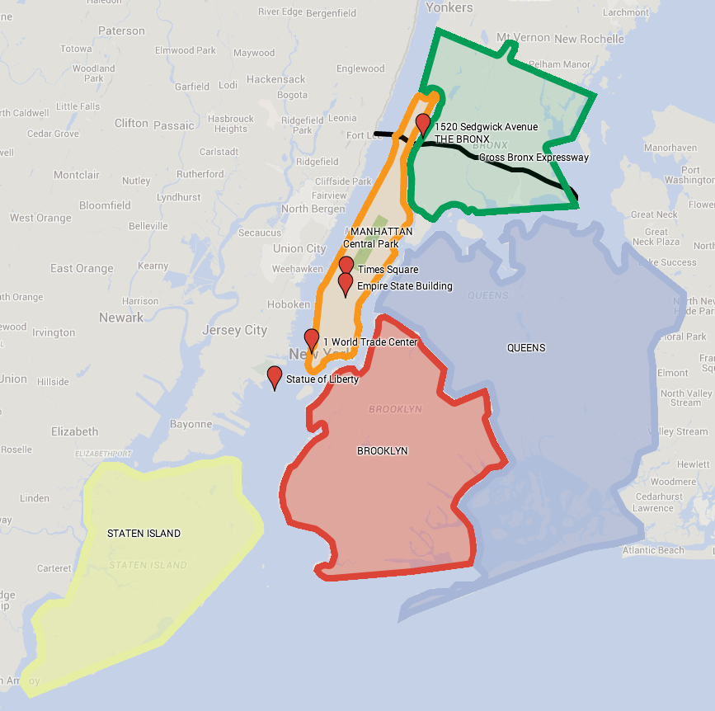
Ask students:
- New York City is broken up into five sections, called “boroughs.” What are each of these five boroughs named?

- What famous landmarks do you notice on this map? In which borough are most of these landmarks located?

- Where is the Bronx in relation to Manhattan, where many of the famous landmarks are found?
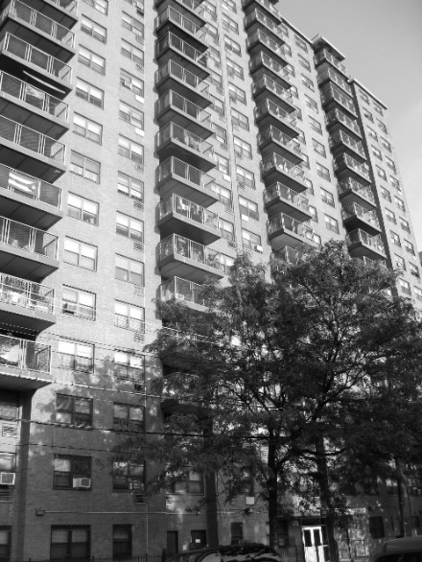
​2. Guide students to the point on the map marked “1520 Sedgwick Avenue” and display image of the building. Explain that this is the address of an apartment building in the Bronx where some of the earliest Hip Hop performances occurred, including several house parties emceed by DJ Kool Herc, a resident of the building.

Ask students:
- Are there any roads or highways demarcated on the map? [Students should find the Cross Bronx Expressway.]

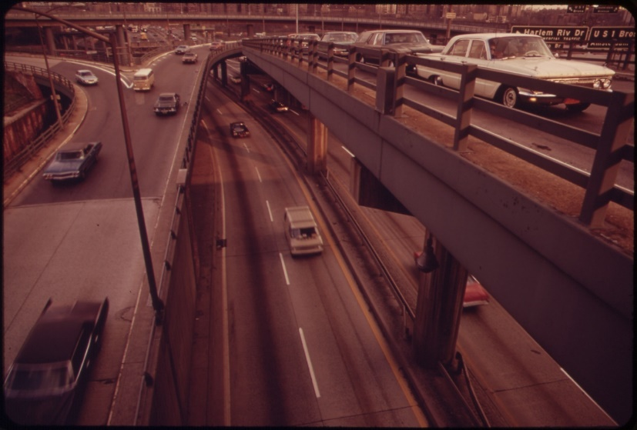
Display photo of the Cross Bronx Expressway. Explain that the expressway was constructed between 1948 and 1972 and was one of the first highways to be built directly through a crowded urban environment. While technologically innovative, its construction deeply affected the communities through which it passed by dividing neighborhoods, lowering property values, and hastening the rate of urban decay in many sections of the Bronx.

3. Direct students back to the map. Ask students:
- What is the proximity between 1520 Sedgwick Avenue and the Cross Bronx Expressway, and how might that affect life at that address? [Students should see that the expressway is right up next to the apartment building.]

4. Distribute Handout 2: Bronx Demographics 1960-2000. Ask the students to answer the following questions about the socioeconomic conditions in the Bronx based on the information in the two charts:
- The population of which racial/ethnic group increased the most in the Bronx between 1960 and 2000? Which population decreased the most?
- What happened to the poverty rate of the total population of the Bronx between 1970 and 2000? What percentage of the total population was in poverty in 1980?
- What overall conclusions can you draw from these charts about the socioeconomic conditions in the Bronx while Hip Hop was developing there in the 1970s?
​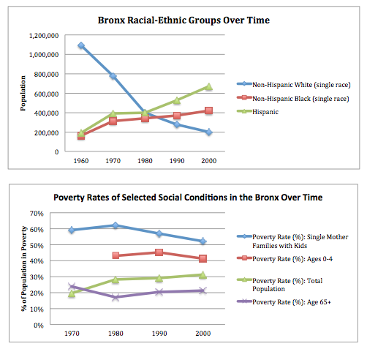
5. Show a video clip from an interview with Hip Hop pioneer Grandmaster Flash. Explain that this news story was produced in 2000 but examines events that occurred in the late 1970s. Discuss as a class:
- Where was early Hip Hop performed? Who was in the audience?
- What equipment did Grandmaster Flash use to build a new musical sound? How did he utilize this equipment in an innovative way?
- What are “the breaks” to which Grandmaster Flash is referring? What is “scratching”? What about the way Hip Hop DJs played this music made it original?
- How does Grandmaster Flash describe the role of the Master of Ceremonies, or MC at a Hip Hop performance?

6. Divide class into small groups of 3–4 students. Distribute Handout 3: New York City Timeline 1960s-1970s, and Handout 4: “The Message” Lyric Excerpts; to each group.
7. Show video excerpt of the song “The Message” by Grandmaster Flash and the Furious Five, recorded in 1982. Inform students that they will work in their groups to analyze the way the song reflects the social conditions of New York City in the 1960s and 1970s. Students should underline specific lines in the song and connect them to specific events from the timeline.

[Note to teacher: The video and song lyrics of “The Message” contain some explicit language. The teacher is advised to assess whether or not these materials are appropriate for their students. Also note that the video clip ends before the third verse, but students should be able to complete the assignment using the lyrics on the handout.]

8. Discuss in groups:
- Why do you think this song was titled “The Message”? What is its message?
- What are the images in the song that reflect life in the city in the 1970s? (e.g. broken glass, vermin, etc.)
9. Poll sample answers from different groups.

10. Reconvene the class and discuss:
- Why do you think Hip Hop became so popular with the people in urban communities such as the Bronx?
- How did “The Message” reflect the social and economic conditions of the Bronx in the 1970s? Think about both the equipment that was needed to produce it and the themes reflected in its lyrics.

[Teacher can emphasize the idea that early Hip Hop required few resources: a turntable or two, speakers, existing records, and a DJ with a lot of imagination; students can compare this to the instruments, equipment, and resources needed to form a rock band.]

Summary Activity:

Considering what you have just learned about the history of Hip Hop music, compose your own verse or two to Grandmaster Flash’s “The Message” that is reflective of the social, political, and/or economic climate that exists today.

