Weekly Lesson- Artistic Contributions
Esmaa Mohamoud
What
Lesson Goal: To view and reflect on art that represents the multiple social identities we have.

Social Identity: The social categories that people inhabit. They can be fluid and changing. They influence how we see ourselves and how others see and treat us.
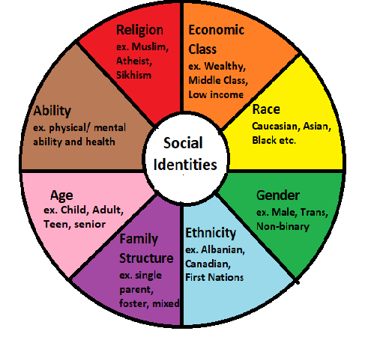

Reflection
In “One of the Boys”, Esmaa creates bold wearable sculptures of basketball jerseys and ball gowns that all at once showcase the role race and gender play in the lives of young Black Canadians. In an interview with the CBC she talks about the sculptures, “They remind me of Disney princesses and my neighbourhood basketball courts all at once”... The installation One of the Boys is a physical articulation of a childhood vision for Mohamoud, delicately balancing the external pressures to be feminine with her childhood desire to wear her Vince Carter jerseys every day. "I was just a little girl who wanted to be Vince Carter and didn't know how to be."

Visit Esmaa Mohamoud’s website to view images from the “One of the Boys” exhibit.
http://esmaamohamoud.com/one-of-the-boyd

As you view the pictures, think about the following questions:

- What social identities do you inhabit (race, gender, culture, economic class etc.)?
Are any of these identities missing from art you normally see?

- Why is it important to represent multiple social identities we have in art?

Works Cited

Jewell, T. & Durand, A. (2020). “This Book Is Anti-Racist: 20 Lessons on How to Wake Up, Take Action, and Do the Work” Minneapolis, MN : Frances Lincoln Children's Books

https://www.cbc.ca/arts/why-esmaa-mohamoud-is-bringing-blackness-and-basketball-into-the-gallery-1.4214080

http://esmaamohamoud.com/one-of-the-boyd

