School of health sciences
EXPLORING biotechnology WORKSHOP FOR HIGH SCHool students

Workshop Highlights

Focused lab sessions and engaging discussions will immerse participants in core biotechnology concepts and techniques. You won't just learn theory; you will discover how scientific discoveries translate into real-world applications and impact industries.

Hands-On Lab Experiences Include:
- DNA Fingerprinting & PCR
- Animal & Plant Cell Culture
- Molecular Cloning & Recombinant DNA

Industry Visit to
Acuitas Therapeutics

On Friday, Dec. 12th students will go to UBC to visit Acuitas Therapeutics, a global leader in mRNA drug delivery known for its pivotal role in vaccine development and cutting-edge CRISPR gene therapies.

DECEMBER 8 – 12, 2025 I BCIT Burnaby Campus & UBC

Uncover the world of biotechnology and see how scientific innovation is shaping our future. This intensive week-long workshop offers a unique opportunity to experience hands-on learning in BCIT teaching laboratories. Work alongside the Biotechnology faculty to master essential techniques and gain a realistic perspective on this dynamic field.

Who Should Apply?
Students in Grades 10-12 with a strong interest in science, research, and innovation.

Important Details
Application Deadline: November 14, 2025
Program Dates: December 8–12, 2025
Locations: BCIT Burnaby Campus + UBC
Contact
Kathy White I kathy_white@bcit.ca I 604-432-8456
Spaces are limited—apply early to secure your spot!
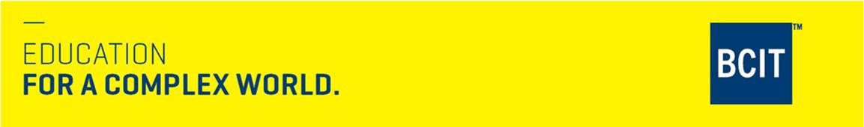
British Columbia Institute of Technology
3700 Willingdon Avenue, Burnaby, British Columbia V5G 3H2
British Columbia Institute of Technology
3700 Willingdon Avenue, Burnaby, British Columbia V5G 3H2
More information: program_advising@bcit.ca | 604.434.1610 | bcit.ca/study/programs/8910bsc

