Office 365 Outlook: Web Users Quick Start

- URL = https://outlook.office.com/owa
This address appears on our district website Staff page and is noted by the link titled: Office 365 Outlook: Migrated Users

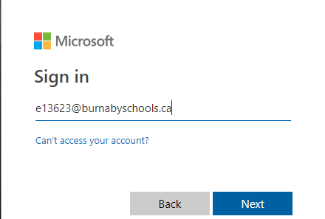
- Enter your email address in the following format: eid@burnabyschools.ca
(e13623@burnabyschools.ca for example)

- Click Next

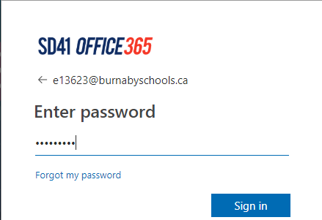
- Enter your Email password

- Click Sign In

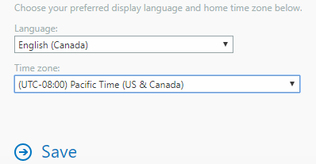
- Choose your preferred Language and Time Zone
  - English (Canada)
  - Pacific Time (US & Canada)
- Click Save

Continued Next Page...
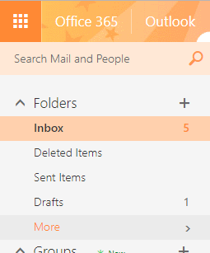
- By default, the application displays your ‘favourite’ folders. To display all your email folders click on the ‘More’ link and the list will expand.

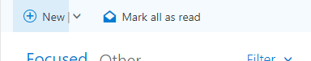
- To send a new Email or create a new Calendar item click on the ‘New’ icon which is at the top of the navigation pane.

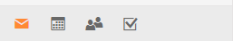
- Your Outlook Calendar, Contacts, and Tasks can all be accessed via the toolbar located at the bottom of the navigation window (bottom left of the screen).

- To log out:
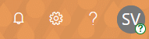
  - Click on your Initials which are located in the upper right of the screen
  - Choose the Sign Out option from the menu.
  - Close the browser once logged out to ensure subsequent users of the computer are not able to access your outlook content.

- Account settings are accessed by clicking on your Initials in the upper right corner or by clicking on the ‘Gear’ icon, which is next to application help.

