Look before you book
The goal of the DLRC is to provide the “right” resources to support your students’ learning. We try to match our resources to the new curriculum and suggest appropriate grade levels.
Recently we have noticed that some kits are being borrowed and returned the next shipping day. This seems to indicate that the requested resource was not what the teacher wanted or expected. So here are some tips to make sure you are booking the appropriate resources for your classroom.
You can also contact the DLRC staff to assist you to find appropriate resources by email dlrcloans@sd41.bc.ca or phone 604 296-6934 and press #1.
LOOK at the catalog record.
Each record describes the nature of the kit, often including curricular objectives or intention. You also can see the recommended grade levels, the associated subjects or topics that this kit supports and the number of items in the kit. The contents list includes the titles of all the books, media and/or equipment. You can see if the titles or items fit your needs.
If you see “CALL DLRC (639903) TO BOOK” next to the title of a resource it means you need to phone to book the item as it is too large or bulky to be delivered on a regular district mail day (Tuesdays and Thursdays). Delivery and pickup dates need to be set up as part of the booking.

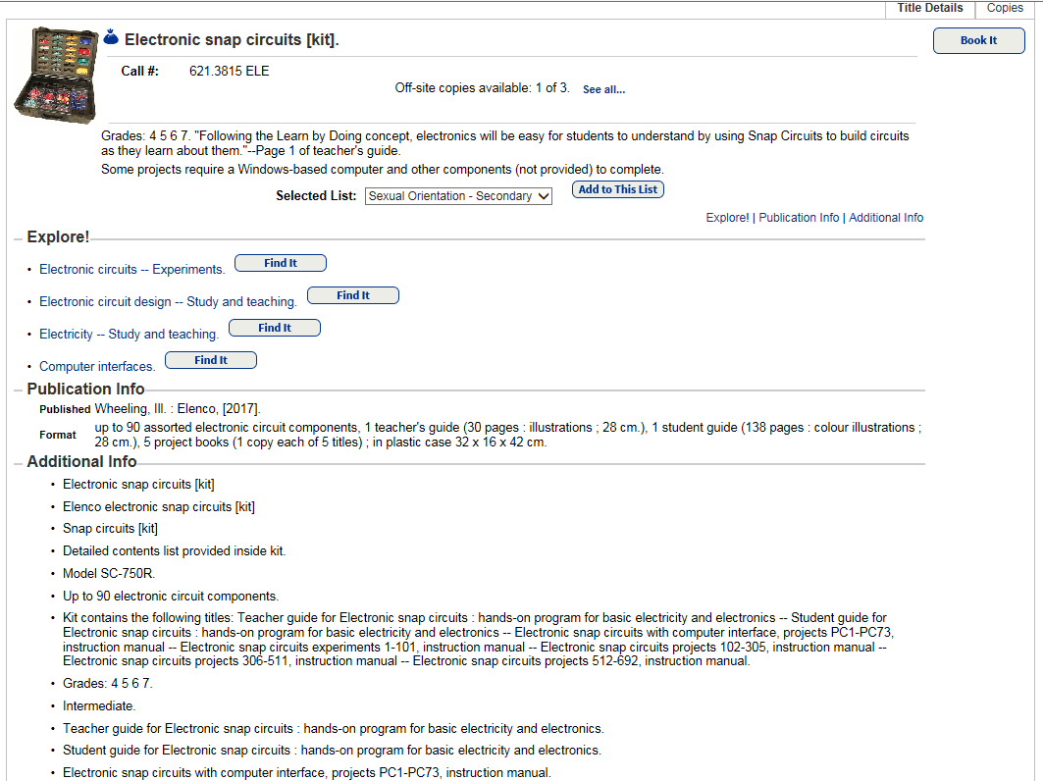
List of kit contents
Subjects and topics
Recommended grade levels and description of item.

LOOK at the booking request page with the calendar.
You can see the maximum number of days for the loan period. Plan accordingly to make sure you can complete your use of this item within this timeframe.
Look at the calendar and arrow forward to the date you would like to receive the item. Then go forward one month past your request date to ensure it is available for the full loan period – all days should be in white! Red means the item is already booked for those dates.
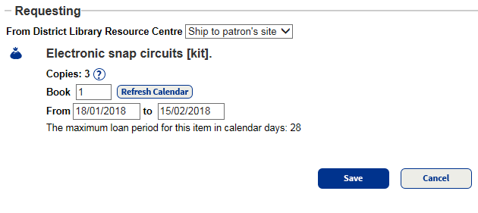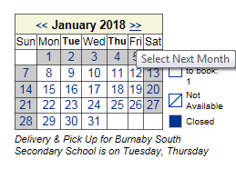
Check the loan period and dates.
If all looks good then Save
Check the following month to make sure your item is available for the full loan period.
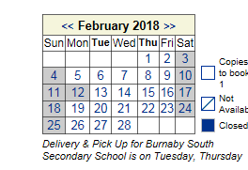

LOOK at your My Info tab to see your bookings from the DLRC
If there is an item on your bookings list that you no longer need then please delete the booking so it will be available for others to borrow.
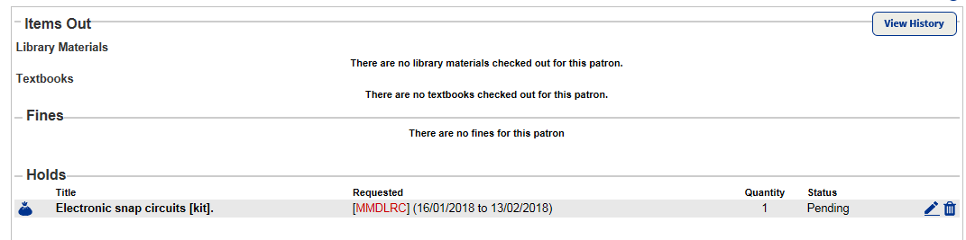
Dates showing the beginning and end of your loan period with this item. Make sure you finish using the item by the return date.
Click on the garbage can to delete your booking.

