Black History Month in Canada 2023
February and Forever: Celebrating Black History today and every day.

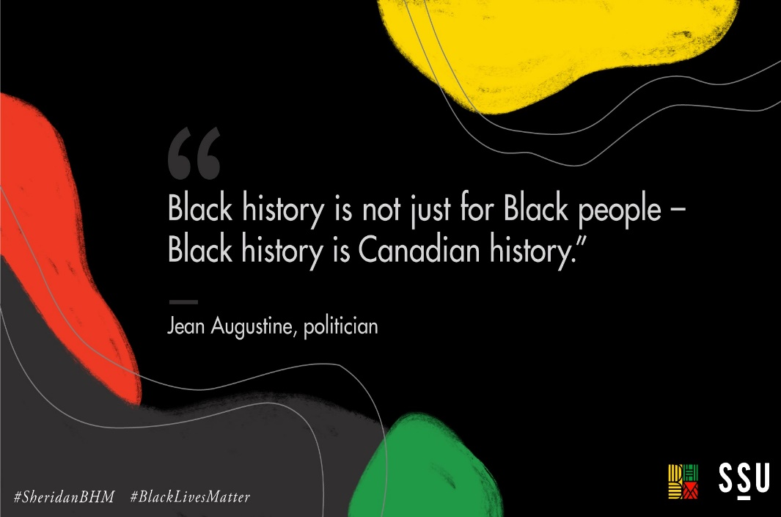
What is Black History Month?
Black History Month is an intentional time of year that provides necessary opportunities for all Canadians to learn more about Black culture, and for us to celebrate the many achievements and contributions of Black people in Canada and beyond. This is a time of year to learn and dig deeper into people, places, cultural impacts, and movements from history to the present day.
We recognize that Black history is Canadian history and should be a focus all year-round, but we also understand that heritage months/celebrations are important because they help explain the stories, complexities and the richness of groups within our larger national identity.
Black History Month has  been celebrated globally since 1926, and it was recognized in our Canadian parliament in 1995 following the initiative of the Honourable Jean Augustine, Canada’s first Black Member of Parliament.  Throughout history, Black Canadians have done so much to make Canada the culturally diverse, compassionate, and prosperous nation we know  today. | What is the focus for Black History Month?  Each year has a global theme and this year’s focus is resilience. We will spend time investigating this theme, but also use the time as an opportunity to celebrate and bring attention to Black joy, achievement and excellence. The events and topics of Black History Month can be adapted to any subject or topic area, either by focusing on content, Black leaders, innovators, Black voices and perspectives.
5 Ways to Honor Black History Month in Canada
- Read a book on a Black Canadian in your discipline
- Listen to a podcast with your class
- Attend a webinar to celebrate Black history month
(and beyond) in Canada
- Watch a video or documentary about the Black experience
- Encourage your students (and your family) to shop
Black-owned businesses
- https://mytoastlife.com/how-to-celebrate-black-history-month-in-canada/

Why us? Why now? Why Here?
Black History is Canadian history!

Black students need to see themselves in the curriculum in a positive way. Other students need to learn that people of African descent have contributed to making society great, something that should be taught throughout the year and not just during the month of February. All of our students’ cultures, histories and accomplishments should be embedded in the curriculum all year long and not just celebrated during specific months. An inclusive, culturally-relevant curriculum with a responsive pedagogy in which students of all diversities can see themselves is critical for learning. - Velma Morgan, VETO
- BHM allows us to reflect on why it is important to learn about Canada’s first Black Cabinet Minister, Commander-in-Chief, about the Coloured Hockey League, the No. 2 Construction Battalion, the Black train porters all named “George”; stories that have rarely been taught in classrooms.

Want to know more about people and events like this?
Scan the QR code to explore 28 days of Black Excellence!

