APA 6TH EDITION
This guide provides examples of some of the most common types of citations you will need to create. However, if you are using a source that doesn’t fall into any of the following categories, check https://owl.english.purdue.edu/owl/resource/560/01/​ for more instruction.

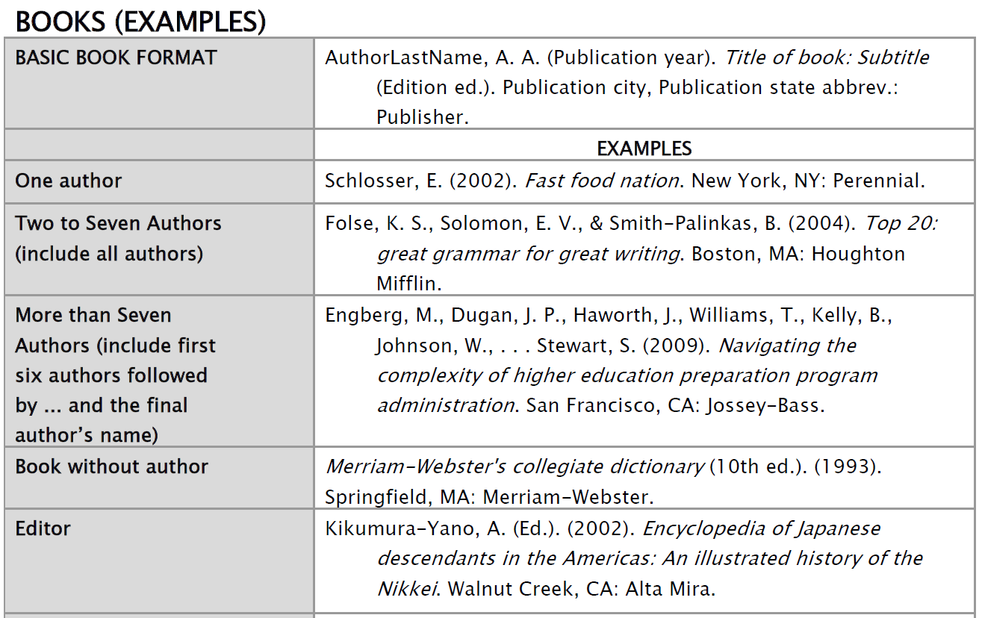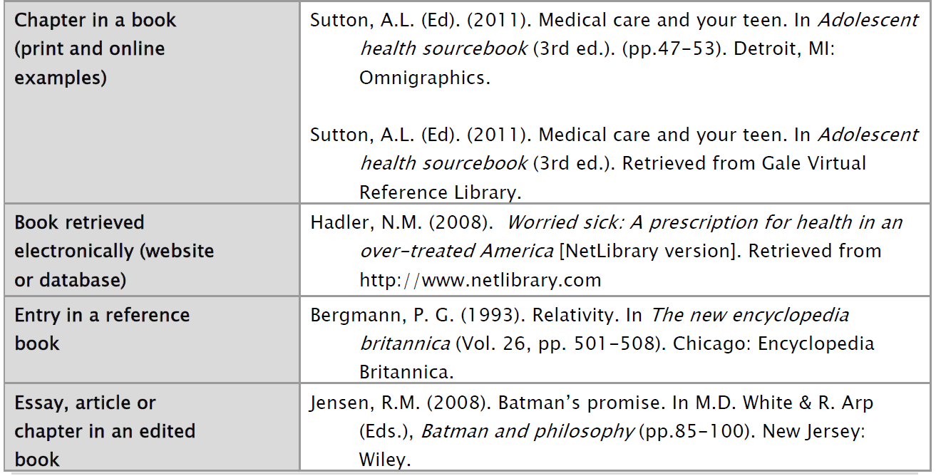
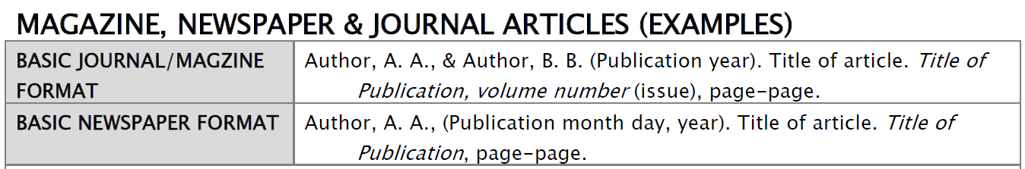
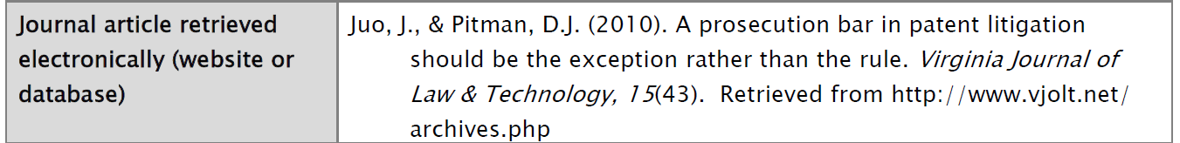
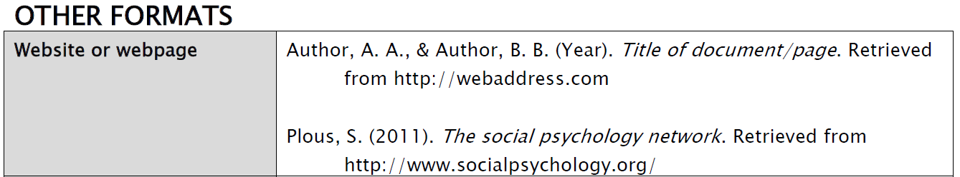
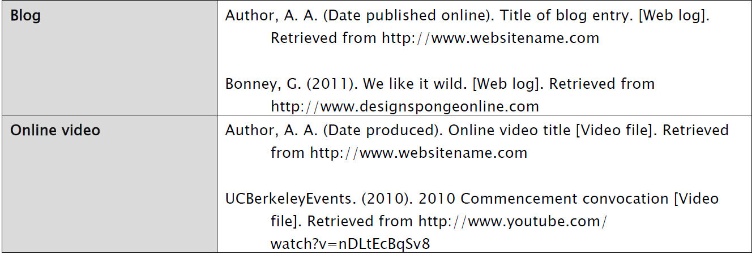
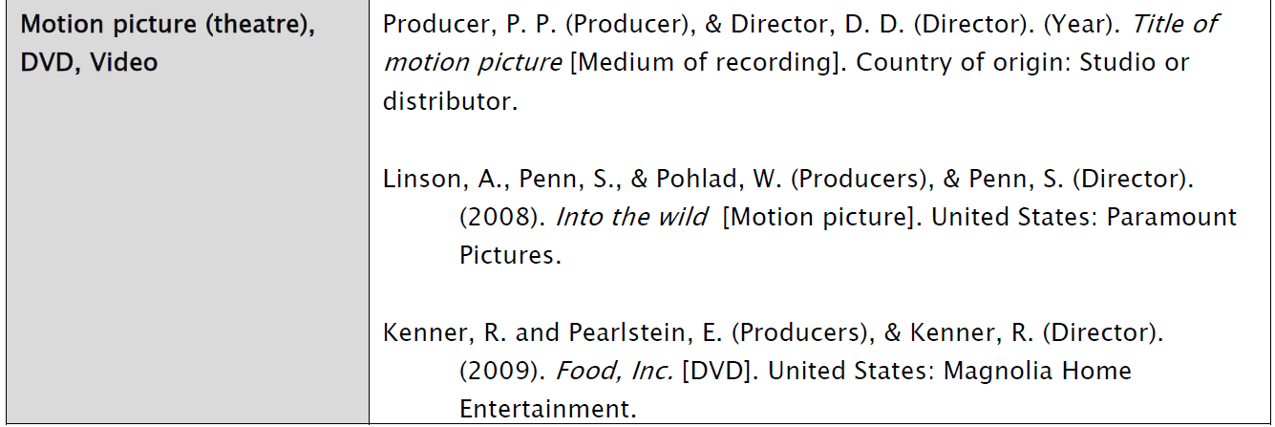
- If no date can be found, write n.d.

IN-TEXT CITATIONS
When quoting from, or paraphrasing a source, you need to include an in-text citation. For APA, you need to include the author/authors’ last name(s), followed by the date of publication and the page #
(author, date, p.#).
- Page numbers are required for a direct quote and recommended for a paraphrased idea.
- The citation should be enclosed in brackets directly after the quotation, or at the end of the sentence, if you are paraphrasing.
- If you include the author’s name before the paraphrase or quotation, you do not need to re-write it in the brackets as well.

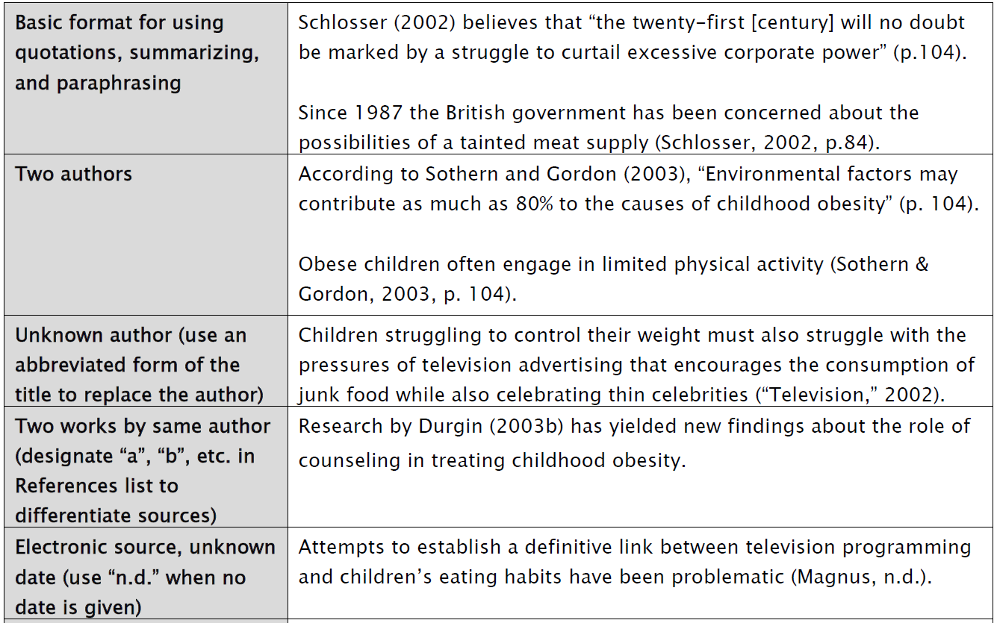
A Work by Three to Five Authors | List all the authors the first time you cite the source. Use the word "and" between the authors' names within the text and use & in the brackets.  (Kernis, Cornell, Sun, Berry, & Harlow, 1993).  The next time you site the same source, only use the first author's last name followed by "et al."  (Kernis et al., 1993)
Six or More Authors: | Use the first author's name followed by et al.  Harris et al. (2001) argued...  (Harris et al., 2001)
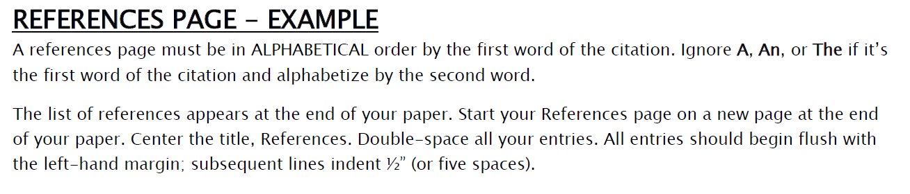
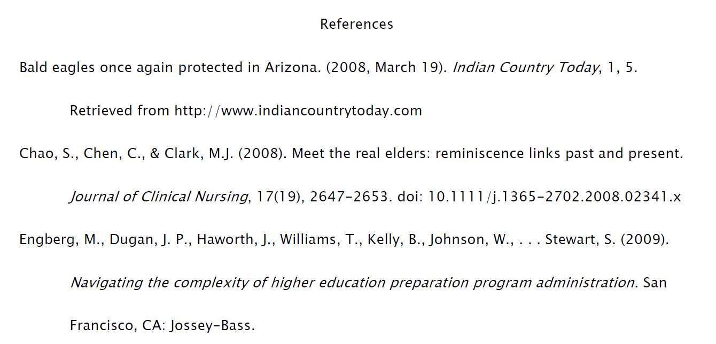

Information for this handout came directly from:
Chabot College. (2009). APA Citation Handout – 6th edition. Retrieved from www.chabotcollege.edu/library/documents/apa2009handout_temporary.pdf

