Creating a Bibliography: Using EasyBib
EasyBib is a very useful website that helps students create properly formatted bibliographies with ease.
A bibliography is a list of all the sources (books, articles, websites, movies, etc.) used when preparing a project or an essay. It is very important to acknowledge all the sources you used in your work, as it is considered plagiarism to take credit for someone else’s ideas or research.
By creating a bibliography you are showing your teacher the effort you put into your resources and helping them to locate all of the sources you used.

Using Easy Bib
- Go to: https://edu.easybib.com/auth/coupon
- Enter the code: Alphahs190
- Register for an account. This will allow you to save your bibliography as you work. You will be able to access it at any time from any computer with internet access.
- Click ‘New Project’ to create a new bibliography
- Give the project a name and select the correct bibliography style. Most teachers will want you to use MLA 8.

Creating a Citation:
Each resource you list on your bibliography is called a citation.
When creating a citation, make sure you select the correct type of resource ie.) website, book journal etc. as each of these are cited differently in a bibliography.
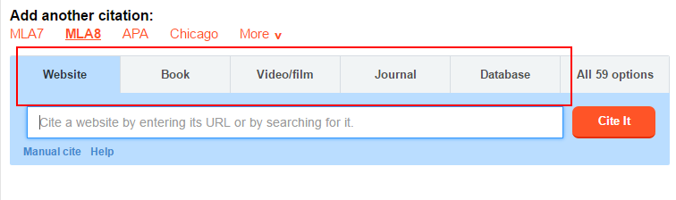

Information you need for each citation
Books
- Author (If there is no author, enter the editor’s name)
- Title
- Publisher name
- Publisher location
- Publication date
Websites
- Author (editor, author, or compiler name, if available)
- Name of the site
- Name of the institution or organization affiliated with the site (sponsor or publisher)
- Date the website was created, or last updated (if available)
- URL (website address)
- The date you visited the site
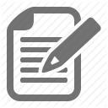
An article in a journal or database
- Author of the article
- Journal or database title
- Year the article was written (if available)
- Volume and issue of the journal (if available)
- Pages of the article (this only applies if the article is available in print form)
- If you are accessing it online: include the URL (website address) and the date you accessed it.
Images
- Image Title (if any)
- Creator name
- Website title
- URL (website address)
- Date the image was created (if given)
- Date you accessed it online

Sample Bibliography

Dean, Cornelia. "Executive on a Mission: Saving the Planet." The New York Times, 22 May 2007, www.nytimes.com/2007/05/22/science/earth/22ander.html?_r=0. Accessed 12 May 2016.
Regas, Diane. “Three Key Energy Policies That Can Help Us Turn the Corner on Climate.” Environmental Defense Fund, 1 June 2016, www.edf.org/blog/2016/06/01/3-key-energy-policies-can-help-us-turn-corner-climate. Accessed 19 July 2016.
Revkin, Andrew C. “Clinton on Climate Change.” The New York Times, 17 May 2007, www.nytimes.com/video/world/americas/1194817109438/clinton-on-climate-change.html. Accessed 29 July 2016.
Shulte, Bret. "Putting a Price on Pollution." US News & World Report, vol. 142, no. 17, 14 May 2007, p. 37. Ebsco, Access no: 24984616.
Uzawa, Hirofumi. Economic Theory and Global Warming. Cambridge UP, 2003.

Formatting

EasyBib should do the formatting for you, but some things to remember about your bibliography are:
- Place it at the end of your paper or project.
- It should begin on a new page and your bibliography should be the only thing on that page.
- Centre the title ‘works cited’ or ‘bibliography’ at the top of the page.
- Begin each entry at the left-hand margin.
- The second (and third) lines of the citation should be indented by 5 spaces.
- Citations should be arranged in alphabetical order (ignore words like a, the, and an when sorting).

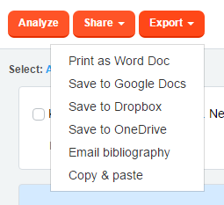
*Remember: Do not just print your bibliography from the EasyBib website. You should either copy and paste it into a word document or export it to another program.
